
Untitled
Report date | Oct 15, 2025 10:26:52 AM

Contents
1. Global Definitions
1.1. Parameters 1
2. Component 1
2.1. Definitions
2.2. Geometry 1
2.3. Materials
2.4. Turbulent Flow, k-ε
2.5. Mesh 1
3. Study 1
3.1. Stationary
3.2. Solver Configurations
4. Results
4.1. Data Sets
4.2. Plot Groups

Global Definitions
Date | Sep 14, 2025 11:59:33 PM

Global settings
Name | Venturi.mph
Path | C:\Users\USER PC\Desktop\MEE 321\Task 6\VENTURI\Venturi.mph
COMSOL version | COMSOL 5.3 (Build: 223)
Unit system | SI

Used products
COMSOL Multiphysics
CFD Module

Parameters 1
Parameters
Name | Expression | Value | Description
D | 42[mm] | 0.042 m | Diameter of pipe, inlet and out
L_in | 180[mm] | 0.18 m | Inlet length
L_out | 110[mm] | 0.11 m | Outlet length
D_t | 15[mm] | 0.015 m | Throat diameter
L_t | 40[mm] | 0.04 m | Throat length
U | 0.011[m/s] | 0.011 m/s | Inlet velocity
x0 | 0[mm] | 0 m
y0 | 0[mm] | 0 m
xt | 220[mm] | 0.22 m
yt | 13.5[mm] | 0.0135 m
x1 | 300[mm] | 0.3 m
y1 | 0[mm] | 0 m

Component 1
Date | Jan 9, 2025 3:09:59 AM

Component settings
Unit system | SI
Geometry shape order | automatic

Definitions
Coordinate Systems
Boundary System 1
Coordinate system type | Boundary system
Tag | sys1

Coordinate names
First | Second | Third
t1 | n | to

Geometry 1
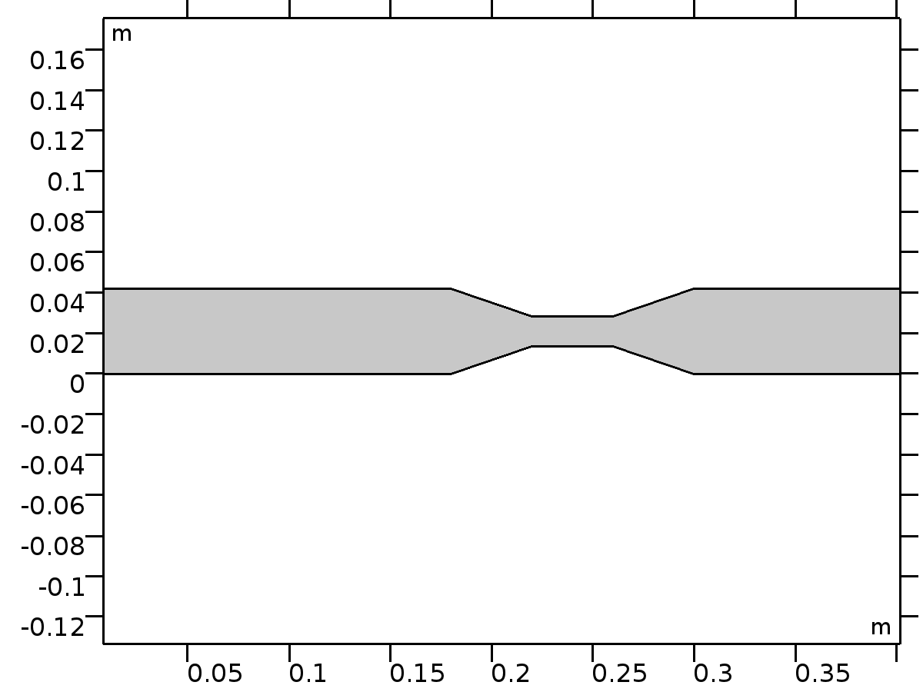
Geometry 1
Units
Length unit | m
Angular unit | deg

Geometry statistics
Description | Value
Space dimension | 2
Number of domains | 1
Number of boundaries | 12
Number of vertices | 12

Rectangle 1 (r1)
Position
Description | Value
Position | {x0, y0}

Size
Description | Value
Width | L_in
Height | D

Rectangle 2 (r2)
Position
Description | Value
Position | {xt, yt}

Size
Description | Value
Width | L_t
Height | D_t

Rectangle 3 (r3)
Position
Description | Value
Position | {x1, y1}

Size
Description | Value
Width | L_out
Height | D

Bézier Polygon 1 (b1)
Polygon segments
Description | Value
Control points | {{0.18, 0.22, 0.22, 0.18}, {0.042, 0.0285, 0.0135, 0}}
Degree | {1, 1, 1}
Weights | {1, 1, 1, 1, 1, 1}
Type | Solid

Bézier Polygon 2 (b2)
Polygon segments
Description | Value
Control points | {{0.3, 0.26, 0.26, 0.3}, {0.042, 0.0285, 0.0135, 0}}
Degree | {1, 1, 1}
Weights | {1, 1, 1, 1, 1, 1}
Type | Solid

Union 1 (uni1)
Compose
Description | Value
Keep interior boundaries | Off

Materials
Water
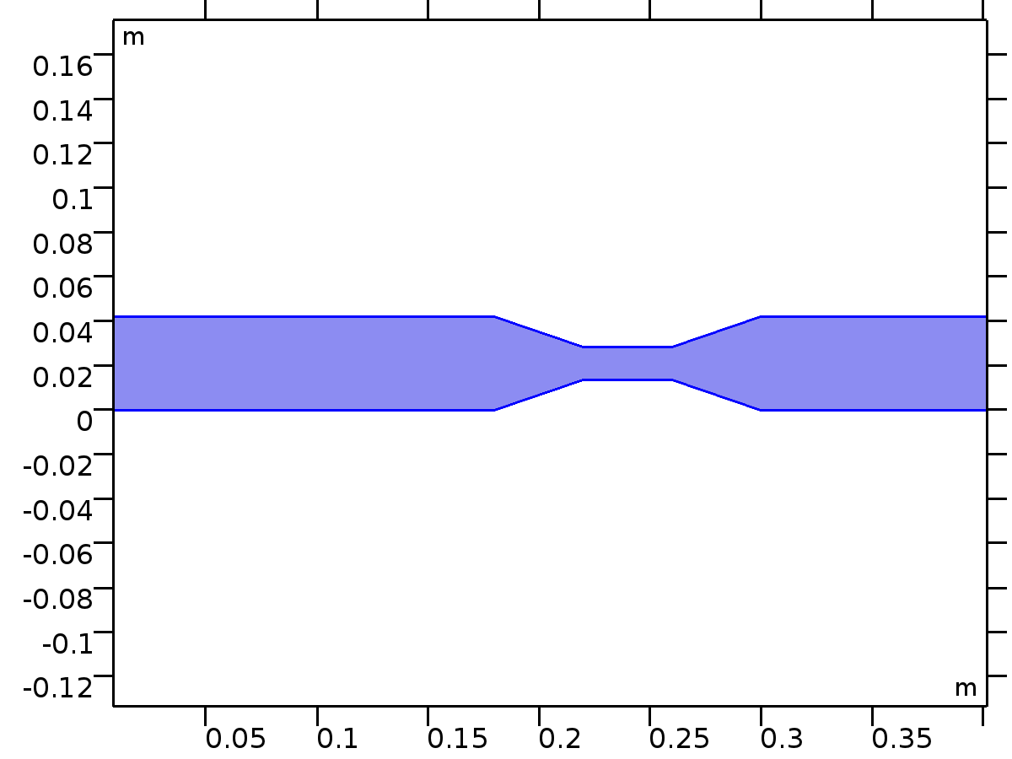
Water
Selection
Geometric entity level | Domain
Selection | Domain 1

Material parameters
Name | Value | Unit
Dynamic viscosity | eta(T[1/K])[Pa*s] | Pa·s
Density | rho(T[1/K])[kg/m^3] | kg/m³

Basic Settings
Description | Value
Dynamic viscosity | eta(T[1/K])[Pa*s]
Ratio of specific heats | 1.0
Electrical conductivity | {{5.5e-6[S/m], 0, 0}, {0, 5.5e-6[S/m], 0}, {0, 0, 5.5e-6[S/m]}}
Heat capacity at constant pressure | Cp(T[1/K])[J/(kg*K)]
Density | rho(T[1/K])[kg/m^3]
Thermal conductivity | {{k(T[1/K])[W/(m*K)], 0, 0}, {0, k(T[1/K])[W/(m*K)], 0}, {0, 0, k(T[1/K])[W/(m*K)]}}
Speed of sound | cs(T[1/K])[m/s]

Functions
Function name | Type
eta | Piecewise
Cp | Piecewise
rho | Piecewise
k | Piecewise
cs | Interpolation

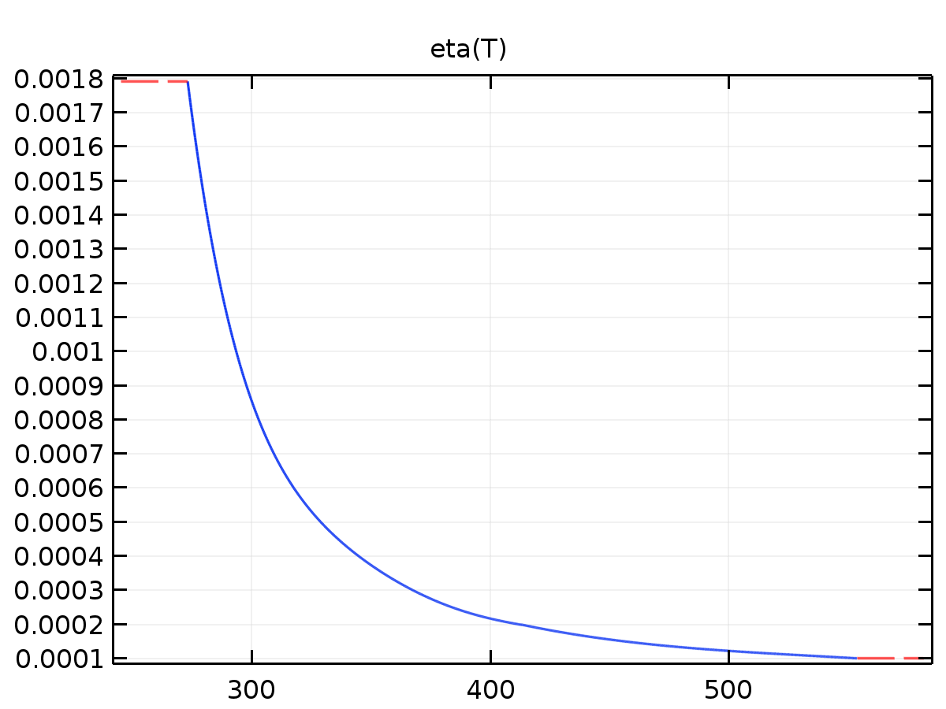
eta
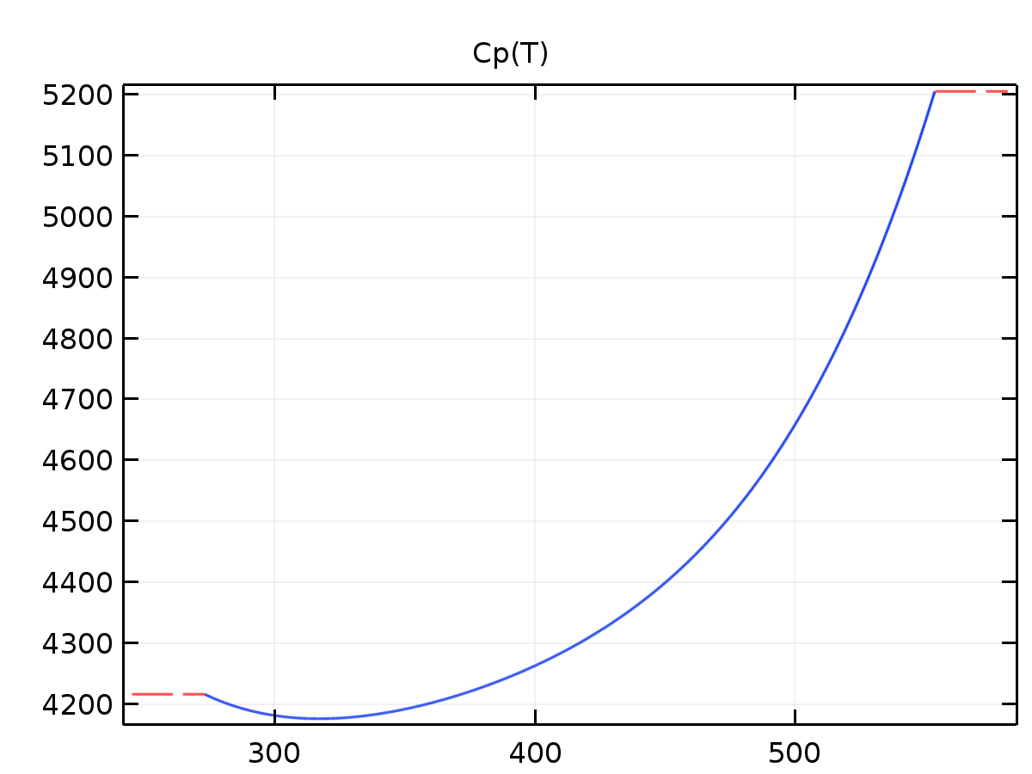
Cp
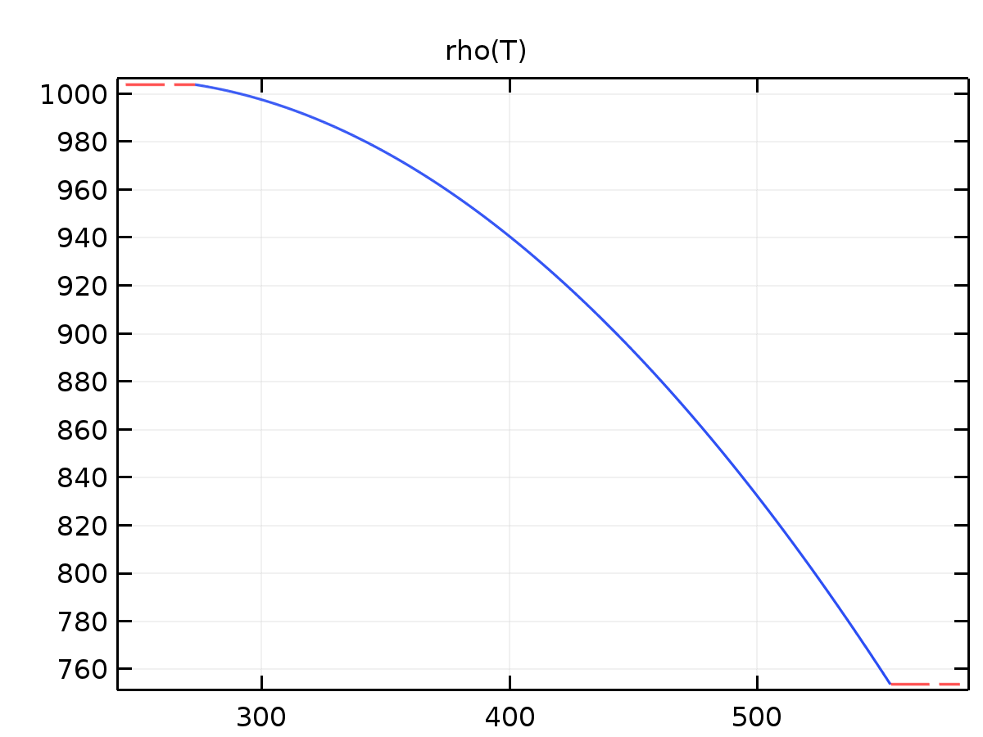
rho
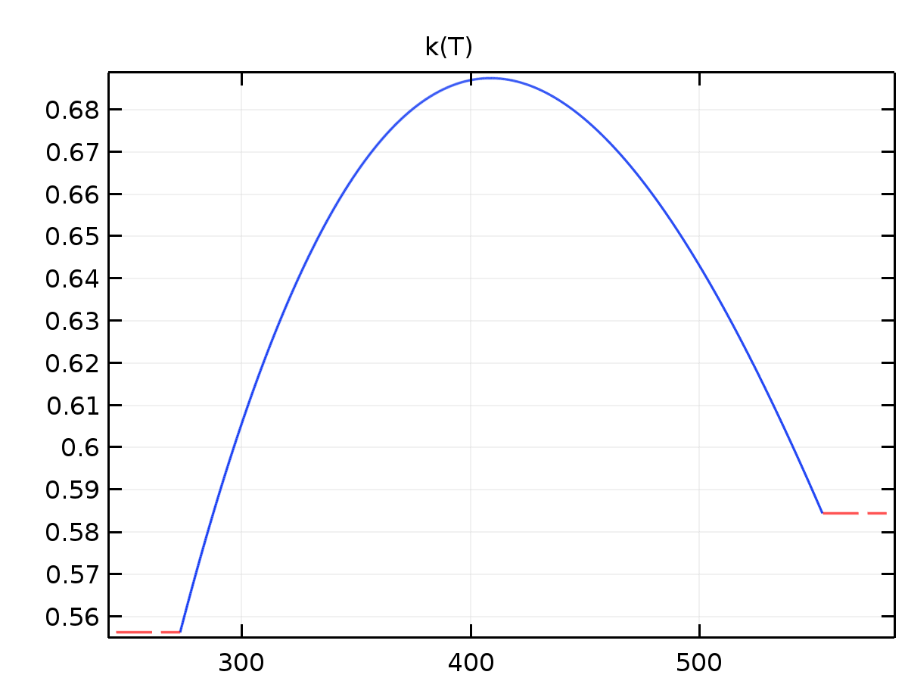
k
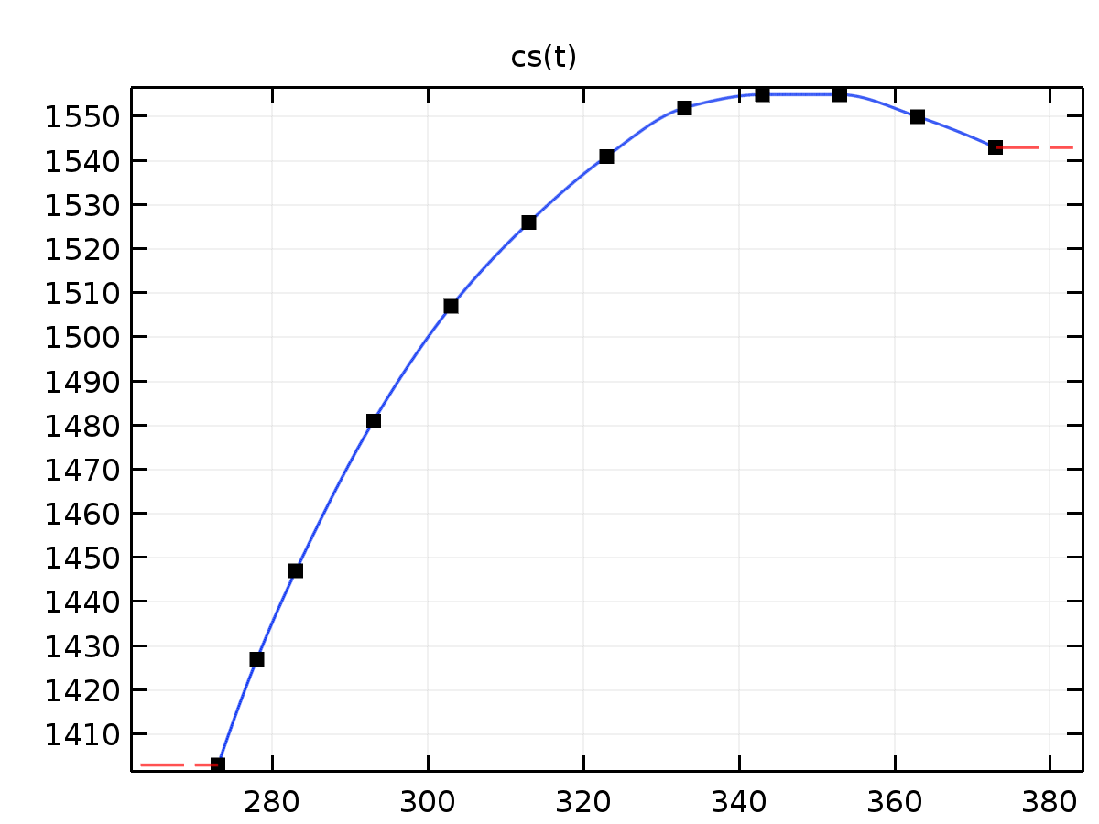
cs
Turbulent Flow, k-ε
Used products
COMSOL Multiphysics
CFD Module

Turbulent Flow, k-ε
Selection
Geometric entity level | Domain
Selection | Domain 1

Equations
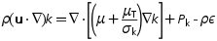
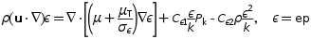
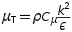
Settings
Description | Value
Discretization of fluids | P1 + P1
Value type when using splitting of complex variables | {Real, Real, Real, Real, Real, Real, Real, Real, Real, Real, Real, Real, Real}
Compressibility | Incompressible flow
Turbulence model type | RANS
Turbulence model | k - ε
Wall treatment | Wall functions
Include gravity | Off
Reference temperature | 293.15[K]
Reference pressure level | 1[atm]
Streamline diffusion | On
Crosswind diffusion | On
Streamline diffusion | On
Crosswind diffusion | On
Isotropic diffusion | Off
Isotropic diffusion | Off
Turbulence model parameter | 1.44
Turbulence model parameter | 1.92
Turbulence model parameter | 0.09
Turbulence model parameter | 1.0
Turbulence model parameter | 1.3
Law of the wall constant | 5.2
Turbulence model parameter | 0.41
Use pseudo time stepping for stationary equation form | On
CFL number expression | Automatic
Velocity scale | 1[m/s]
Length scale factor | 0.035

Variables
Name | Expression | Unit | Description | Selection
spf.Tref | 293.15[K] | K | Reference temperature | Domain 1
spf.dz | 1 | m | Thickness | Domain 1
spf.pref | 1[atm] | Pa | Reference pressure level | Domain 1
spf.pA | p+spf.pref | Pa | Absolute pressure | Domain 1
spf.hasWF | 0 |  | Help variable | Boundaries 1–12
spf.Ceps1 | 1.44 | 1 | Turbulence model parameter | Domain 1
spf.Ceps2 | 1.92 | 1 | Turbulence model parameter | Domain 1
spf.C_mu | 0.09 | 1 | Turbulence model parameter | Domain 1
spf.sigmak | 1 | 1 | Turbulence model parameter | Domain 1
spf.sigmaeps | 1.3 | 1 | Turbulence model parameter | Domain 1
spf.B | 5.2 | 1 | Law of the wall constant | Domain 1
spf.sigmaw | 0.2 | 1 | Smoothing parameter | Domain 1
spf.kappav | 0.41 | 1 | Turbulence model parameter | Domain 1
spf.localCFLvalue | 3+if(niterCMP>=10,1.3^min(-10+niterCMP,7),0)+if(niterCMP>=35,9*1.3^min(-35+niterCMP,9),0)+if(niterCMP>=65,90*1.3^min(-65+niterCMP,9),0) |  |  | Domain 1
spf.locCFL | CFLCMP | 1 | Local CFL number | Domain 1
spf.time_step_inv | max(sqrt(emetric_spatial(u,v)*2^gmg_level^2),spf.mu/(spf.rho*(0.25*spf.l_mix_lim)^2)) | Hz | Inverse time step | Domain 1
spf.nx | dnx | 1 | Normal vector, x component | Boundaries 1–12
spf.ny | dny | 1 | Normal vector, y component | Boundaries 1–12
spf.nz | 0 | 1 | Normal vector, z component | Boundaries 1–12
spf.nxmesh | dnxmesh | 1 | Normal vector, x component | Boundaries 1–12
spf.nymesh | dnymesh | 1 | Normal vector, y component | Boundaries 1–12
spf.nzmesh | 0 | 1 | Normal vector, z component | Boundaries 1–12

Weak expressions
Weak expression | Integration order | Integration frame | Selection
-spf.rho*nojac(spf.time_step_inv/spf.locCFL)*(ep-nojac(ep))*test(ep) | 2 | Spatial | Domain 1
-spf.rho*nojac(spf.time_step_inv/spf.locCFL)*(k-nojac(k))*test(k) | 2 | Spatial | Domain 1
spf.rho*nojac(spf.time_step_inv/spf.locCFL)*(-(u-nojac(u))*test(u)-(v-nojac(v))*test(v)) | 2 | Spatial | Domain 1

Fluid Properties 1
Fluid Properties 1
Selection
Geometric entity level | Domain
Selection | Domain 1

Equations
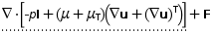
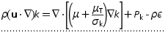
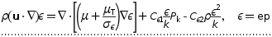
Settings
Description | Value
Mixing length limit | Automatic
Density | From material
Dynamic viscosity | From material
Temperature | User defined
Temperature | 293.15[K]

Properties from material
Property | Material | Property group
Density | Water | Basic
Dynamic viscosity | Water | Basic

Variables
Name | Expression | Unit | Description | Selection
spf.k_nn | max(k,0) | m²/s² | Regularized turbulent kinetic energy | Domain 1
spf.rho | subst(material.rho,spf.fp1.minput_temperature,spf.Tref,spf.pA,spf.pref) | kg/m³ | Density | Domain 1
spf.mu | subst(material.mu,spf.fp1.minput_temperature,spf.Tref) | Pa·s | Dynamic viscosity | Domain 1
spf.muinit | spf.mu | Pa·s | Dynamic viscosity | Domain 1
spf.rhoinit | subst(spf.rho,spf.fp1.minput_pressure,1[atm]) | kg/m³ | Density | Domain 1
spf.l_mix_lim | 2*spf.lref | m | Mixing length limit | Domain 1
spf.gammaT | nojac(spf.C_mu*spf.rho*spf.k_nn/spf.muT) | 1/s | Turbulence help variable | Domain 1
spf.tauT | 1/spf.gammaT | s | Turbulence time scale | Domain 1
spf.ep_nn | max(ep,0) | m²/s³ | Regularized turbulent dissipation rate | Domain 1
spf.muT | nojac(max(spf.rho*spf.lsubstar*sqrt(spf.k_nn),0.5*spf.mu)) | Pa·s | Turbulent dynamic viscosity | Domain 1
spf.ep_pos | max(ep,eps) | m²/s³ |  | Domain 1
spf.Sxx | ux | 1/s | Strain rate, xx component | Domain 1
spf.Syx | 0.5*(vx+uy) | 1/s | Strain rate, yx component | Domain 1
spf.Szx | 0 | 1/s | Strain rate, zx component | Domain 1
spf.Sxy | 0.5*(uy+vx) | 1/s | Strain rate, xy component | Domain 1
spf.Syy | vy | 1/s | Strain rate, yy component | Domain 1
spf.Szy | 0 | 1/s | Strain rate, zy component | Domain 1
spf.Sxz | 0 | 1/s | Strain rate, xz component | Domain 1
spf.Syz | 0 | 1/s | Strain rate, yz component | Domain 1
spf.Szz | 0 | 1/s | Strain rate, zz component | Domain 1
spf.AbsS | sqrt(spf.Sxx^2+spf.Sxy^2+spf.Sxz^2+spf.Syx^2+spf.Syy^2+spf.Syz^2+spf.Szx^2+spf.Szy^2+spf.Szz^2) | 1/s | Absolute strain rate | Domain 1
spf.rF | sqrt(2)/(3*max(spf.AbsS,eps)) | s | Help variable | Domain 1
spf.rFInv | 3*spf.AbsS/sqrt(2) | 1/s | Help variable | Domain 1
spf.lcore | min(spf.C_mu*spf.k_nn^1.5/spf.ep_pos,sqrt(spf.k_nn)*spf.rF) | m | Help variable | Domain 1
spf.lsubstar | nojac(min(spf.lcore,spf.l_mix_lim)) | m | Limited mixing length | Domain 1
spf.nuT | spf.muT/spf.rho | m²/s | Turbulent kinematic viscosity | Domain 1
spf.linSCk | -spf.rho*spf.gammaT | kg/(m³·s) | Linear source term coefficient, k-equation | Domain 1
spf.linSCeps | -spf.rho*spf.Ceps2*spf.gammaT | kg/(m³·s) | Linear source term coefficient | Domain 1
spf.PCore | 2*ux^2+uy*(uy+vx)+vx*(uy+vx)+2*vy^2 | 1/s² | Turbulent kinetic energy source term | Domain 1
spf.Pk | nojac(max(spf.muT*spf.PCore,0)) | W/m³ | Turbulent kinetic energy source term | Domain 1
spf.Peps | nojac(max(spf.Ceps1*spf.gammaT*spf.muT*spf.PCore,0)) | Pa/s² |  | Domain 1
spf.kinit | (100*spf.muinit/(spf.rhoinit*spf.l_mix_lim))^2 | m²/s² | Turbulent kinetic energy | Domain 1
spf.epinit | 10*spf.C_mu*spf.kinit^1.5/spf.l_mix_lim | m²/s³ | Turbulent dissipation rate | Domain 1
spf.epsilon_p | 1 | 1 | Porosity | Domain 1
spf.Fst_tensorxx | 0 | N/m² | Surface tension force, xx component | Domain 1
spf.Fst_tensoryx | 0 | N/m² | Surface tension force, yx component | Domain 1
spf.Fst_tensorzx | 0 | N/m² | Surface tension force, zx component | Domain 1
spf.Fst_tensorxy | 0 | N/m² | Surface tension force, xy component | Domain 1
spf.Fst_tensoryy | 0 | N/m² | Surface tension force, yy component | Domain 1
spf.Fst_tensorzy | 0 | N/m² | Surface tension force, zy component | Domain 1
spf.Fst_tensorxz | 0 | N/m² | Surface tension force, xz component | Domain 1
spf.Fst_tensoryz | 0 | N/m² | Surface tension force, yz component | Domain 1
spf.Fst_tensorzz | 0 | N/m² | Surface tension force, zz component | Domain 1
spf.rhoref | subst(material.rho,spf.fp1.minput_temperature,spf.Tref,spf.pA,spf.pref) | kg/m³ | Reference density | Domain 1
spf.sr | sqrt(0.5*(4*ux^2+2*(uy+vx)^2+4*vy^2)+eps) | 1/s | Shear rate | Domain 1
spf.divu | ux+vy | 1/s | Divergence of velocity field | Domain 1
spf.Fx | 0 | N/m³ | Volume force, x component | Domain 1
spf.Fy | 0 | N/m³ | Volume force, y component | Domain 1
spf.Fz | 0 | N/m³ | Volume force, z component | Domain 1
spf.U | sqrt(u^2+v^2) | m/s | Velocity magnitude | Domain 1
spf.vorticityx | 0 | 1/s | Vorticity field, x component | Domain 1
spf.vorticityy | 0 | 1/s | Vorticity field, y component | Domain 1
spf.vorticityz | vx-uy | 1/s | Vorticity field, z component | Domain 1
spf.vort_magn | sqrt(spf.vorticityx^2+spf.vorticityy^2+spf.vorticityz^2) | 1/s | Vorticity magnitude | Domain 1
spf.cellRe | 0.25*spf.rho*sqrt(emetric_spatial(u-d(x,TIME),v-d(y,TIME))/emetric2_spatial)/spf.mu | 1 | Cell Reynolds number | Domain 1
spf.nu | spf.mu/spf.rho | m²/s | Kinematic viscosity | Domain 1
spf.betaT | 0 | 1/Pa | Isothermal compressibility coefficient | Domain 1
spf.helpCont | -spf.rho*spf.divu | kg/(m³·s) | Help variable | Domain 1
spf.Fgtotx | 0 | N/m³ | Gravity force, x component | Domain 1
spf.Fgtoty | 0 | N/m³ | Gravity force, y component | Domain 1
spf.Fgtotz | 0 | N/m³ | Gravity force, z component | Domain 1
spf.mu_eff | spf.mu+spf.muT | Pa·s | Dynamic viscosity | Domain 1
spf.T_stressx | spf.K_stressx-p*spf.nxmesh | N/m² | Total stress, x component | Boundaries 1–12
spf.T_stressy | spf.K_stressy-p*spf.nymesh | N/m² | Total stress, y component | Boundaries 1–12
spf.T_stressz | spf.K_stressz-p*spf.nzmesh | N/m² | Total stress, z component | Boundaries 1–12
spf.K_stressx | spf.mu_eff*(2*ux*spf.nxmesh+(uy+vx)*spf.nymesh) | N/m² | Viscous stress, x component | Boundaries 1–12
spf.K_stressy | spf.mu_eff*((vx+uy)*spf.nxmesh+2*vy*spf.nymesh) | N/m² | Viscous stress, y component | Boundaries 1–12
spf.K_stressz | 0 | N/m² | Viscous stress, z component | Boundaries 1–12
spf.K_stress_tensorxx | 2*spf.mu_eff*ux | N/m² | Viscous stress tensor, xx component | Domain 1
spf.K_stress_tensoryx | spf.mu_eff*(vx+uy) | N/m² | Viscous stress tensor, yx component | Domain 1
spf.K_stress_tensorzx | 0 | N/m² | Viscous stress tensor, zx component | Domain 1
spf.K_stress_tensorxy | spf.mu_eff*(uy+vx) | N/m² | Viscous stress tensor, xy component | Domain 1
spf.K_stress_tensoryy | 2*spf.mu_eff*vy | N/m² | Viscous stress tensor, yy component | Domain 1
spf.K_stress_tensorzy | 0 | N/m² | Viscous stress tensor, zy component | Domain 1
spf.K_stress_tensorxz | 0 | N/m² | Viscous stress tensor, xz component | Domain 1
spf.K_stress_tensoryz | 0 | N/m² | Viscous stress tensor, yz component | Domain 1
spf.K_stress_tensorzz | 0 | N/m² | Viscous stress tensor, zz component | Domain 1
spf.K_stress_tensor_testxx | 2*spf.mu_eff*test(ux) | N/m² | Viscous stress tensor test, xx component | Domain 1
spf.K_stress_tensor_testyx | spf.mu_eff*(test(vx)+test(uy)) | N/m² | Viscous stress tensor test, yx component | Domain 1
spf.K_stress_tensor_testzx | 0 | N/m² | Viscous stress tensor test, zx component | Domain 1
spf.K_stress_tensor_testxy | spf.mu_eff*(test(uy)+test(vx)) | N/m² | Viscous stress tensor test, xy component | Domain 1
spf.K_stress_tensor_testyy | 2*spf.mu_eff*test(vy) | N/m² | Viscous stress tensor test, yy component | Domain 1
spf.K_stress_tensor_testzy | 0 | N/m² | Viscous stress tensor test, zy component | Domain 1
spf.K_stress_tensor_testxz | 0 | N/m² | Viscous stress tensor test, xz component | Domain 1
spf.K_stress_tensor_testyz | 0 | N/m² | Viscous stress tensor test, yz component | Domain 1
spf.K_stress_tensor_testzz | 0 | N/m² | Viscous stress tensor test, zz component | Domain 1
spf.upwind_helpx | u-d(x,TIME) | m/s | Upwind term, x component | Domain 1
spf.upwind_helpy | v-d(y,TIME) | m/s | Upwind term, y component | Domain 1
spf.upwind_helpz | 0 | m/s | Upwind term, z component | Domain 1
spf.isSPF | 1 | 1 | Help variable | Domain 1
spf.isMPF | 0 | 1 | Help variable | Domain 1
spf.tau_vdxx | 2*spf.mu*ux | Pa | Viscous stress tensor, xx component | Domain 1
spf.tau_vdyx | spf.mu*(vx+uy) | Pa | Viscous stress tensor, yx component | Domain 1
spf.tau_vdzx | 0 | Pa | Viscous stress tensor, zx component | Domain 1
spf.tau_vdxy | spf.mu*(uy+vx) | Pa | Viscous stress tensor, xy component | Domain 1
spf.tau_vdyy | 2*spf.mu*vy | Pa | Viscous stress tensor, yy component | Domain 1
spf.tau_vdzy | 0 | Pa | Viscous stress tensor, zy component | Domain 1
spf.tau_vdxz | 0 | Pa | Viscous stress tensor, xz component | Domain 1
spf.tau_vdyz | 0 | Pa | Viscous stress tensor, yz component | Domain 1
spf.tau_vdzz | 0 | Pa | Viscous stress tensor, zz component | Domain 1
spf.Qvd | spf.tau_vdxx*ux+spf.tau_vdxy*uy+spf.tau_vdyx*vx+spf.tau_vdyy*vy+spf.rho*spf.ep_nn | W/m³ | Viscous dissipation | Domain 1
spf.lref | 0.021000000000000005 | m | Reference length | Domain 1
spf.res_k | -(spf.mu+spf.muT/spf.sigmak)*(kxx+kyy)-spf.linSCk*k-spf.Pk+spf.rho*u*kx+spf.rho*v*ky | W/m³ | Turbulent kinetic energy equation residual | Domain 1
spf.res_ep | -(spf.mu+spf.muT/spf.sigmaeps)*(epxx+epyy)-spf.linSCeps*ep-spf.Peps+spf.rho*u*epx+spf.rho*v*epy | Pa/s² | Turbulent dissipation rate equation residual | Domain 1
spf.res_u | px+spf.rho*u*ux+spf.rho*v*uy-(d(2*ux,x)+d(uy+vx,y))*(spf.mu+spf.muT)-spf.Fx | N/m³ | Equation residual | Domain 1
spf.res_v | spf.rho*u*vx+py+spf.rho*v*vy-(d(vx+uy,x)+d(2*vy,y))*(spf.mu+spf.muT)-spf.Fy | N/m³ | Equation residual | Domain 1
spf.res_p | spf.rho*spf.divu | kg/(m³·s) | Pressure equation residual | Domain 1

Shape functions
Name | Shape function | Unit | Description | Shape frame | Selection
u | Lagrange (Linear) | m/s | Velocity field, x component | Spatial | Domain 1
v | Lagrange (Linear) | m/s | Velocity field, y component | Spatial | Domain 1
p | Lagrange (Linear) | Pa | Pressure | Spatial | Domain 1
k | Lagrange (Linear) | m²/s² | Turbulent kinetic energy | Spatial | Domain 1
ep | Lagrange (Linear) | m²/s³ | Turbulent dissipation rate | Spatial | Domain 1

Weak expressions
Weak expression | Integration order | Integration frame | Selection
-test(kx)*(spf.mu+spf.muT/spf.sigmak)*kx-test(ky)*(spf.mu+spf.muT/spf.sigmak)*ky-spf.rho*(u*kx+v*ky)*test(k)+spf.Pk*test(k)+spf.linSCk*k*test(k) | 2 | Spatial | Domain 1
-test(epx)*(spf.mu+spf.muT/spf.sigmaeps)*epx-test(epy)*(spf.mu+spf.muT/spf.sigmaeps)*epy-spf.rho*(u*epx+v*epy)*test(ep)+spf.Peps*test(ep)+spf.linSCeps*ep*test(ep) | 2 | Spatial | Domain 1
-spf.crosswindep-spf.crosswindk | 2 | Spatial | Domain 1
spf.streamlinek | 2 | Spatial | Domain 1
spf.streamlineep | 2 | Spatial | Domain 1
(p-spf.K_stress_tensorxx)*test(ux)-spf.K_stress_tensorxy*test(uy)-spf.K_stress_tensoryx*test(vx)+(p-spf.K_stress_tensoryy)*test(vy) | 2 | Spatial | Domain 1
spf.Fx*test(u)+spf.Fy*test(v) | 2 | Spatial | Domain 1
spf.rho*(-(d(u,x)*u+d(u,y)*v)*test(u)-(d(v,x)*u+d(v,y)*v)*test(v)) | 2 | Spatial | Domain 1
-spf.rho*spf.divu*test(p)*spf.isSPF | 2 | Spatial | Domain 1
-spf.divu*test(p)*spf.isMPF | 2 | Spatial | Domain 1
spf.streamlinens | 2 | Spatial | Domain 1
spf.crosswindns | 2 | Spatial | Domain 1

Initial Values 1
Initial Values 1
Selection
Geometric entity level | Domain
Selection | Domain 1

Settings
Description | Value
Velocity field, x component | 0
Velocity field, y component | 0
Velocity field, z component | 0
Pressure | 0
Turbulent kinetic energy | spf.kinit
Turbulent dissipation rate | spf.epinit

Variables
Name | Expression | Unit | Description | Selection
spf.u_initx | 0 | m/s | Velocity field, x component | Domain 1
spf.u_inity | 0 | m/s | Velocity field, y component | Domain 1
spf.u_initz | 0 | m/s | Velocity field, z component | Domain 1
spf.p_init | 0 | Pa | Pressure | Domain 1
spf.k_init | spf.kinit | m²/s² | Turbulent kinetic energy | Domain 1
spf.ep_init | spf.epinit | m²/s³ | Turbulent dissipation rate | Domain 1

Wall 1
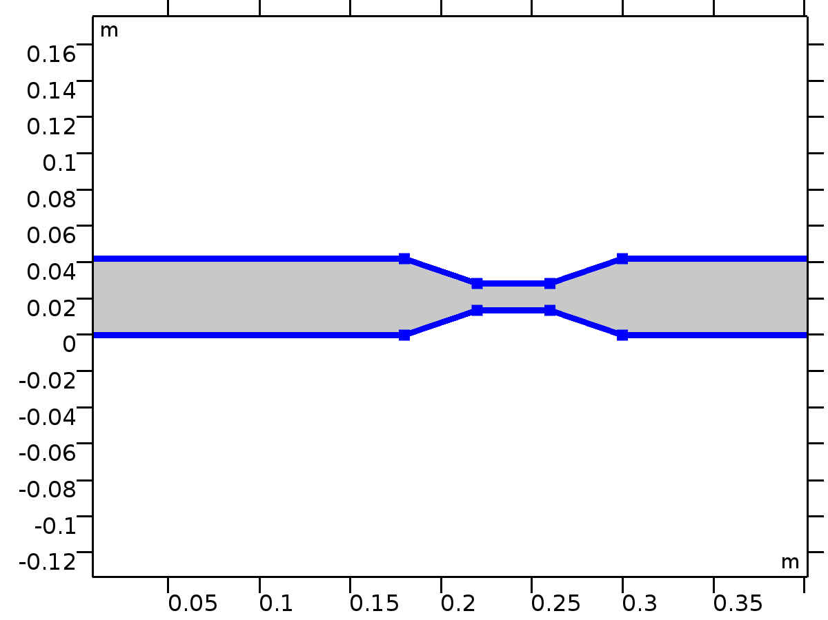
Wall 1
Selection
Geometric entity level | Boundary
Selection | Boundaries 2–11

Equations
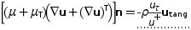
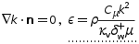
Settings
Description | Value
Wall condition | No slip
Translational velocity | Automatic from frame
Sliding wall | Off
Apply reaction terms on | Individual dependent variables
Use weak constraints | Off
Constraint method | Elemental
Apply wall roughness | Off

Variables
Name | Expression | Unit | Description | Selection
spf.hasWF | 1 |  | Help variable | Boundaries 2–11
spf.k_nn | max(k,0) | m²/s² | Regularized turbulent kinetic energy | Boundaries 2–11
spf.ubndx | 0 | m/s | Velocity at boundary, x component | Boundaries 2–11
spf.ubndy | 0 | m/s | Velocity at boundary, y component | Boundaries 2–11
spf.ubndz | 0 | m/s | Velocity at boundary, z component | Boundaries 2–11
spf.rhoFace | down(spf.rho) | kg/m³ | Density face value | Boundaries 2–11
spf.c_here | 24*nojac(down(spf.mu+spf.muT)/down(1))*spf.meshVol/spf.meshVolInt | 1 | Intermediate variable | Boundaries 2–11
spf.meshVol | meshvol | m |  | Boundaries 2–11
spf.meshVolInt | down(meshvol) | m² | Volume of interior mesh element | Boundaries 2–11
spf.umxTnFace | (spf.upwind_helpx*spf.nxmesh+spf.upwind_helpy*spf.nymesh+spf.upwind_helpz*spf.nzmesh<0)*(spf.upwind_helpx*spf.nxmesh+spf.upwind_helpy*spf.nymesh+spf.upwind_helpz*spf.nzmesh) | m/s | Relative velocity on face | Boundaries 2–11
spf.upwind_ns | spf.rhoFace*spf.umxTnFace*spf.unJump*test(spf.un_here)/down(1)^2 | Pa | Upwind term | Boundaries 2–11
spf.uLeakagex | 0 | m/s | Leakage velocity, x component | Boundaries 2–11
spf.uLeakagey | 0 | m/s | Leakage velocity, y component | Boundaries 2–11
spf.uLeakagez | 0 | m/s | Leakage velocity, z component | Boundaries 2–11
spf.un_here | u*nojac(spf.nxmesh)+v*nojac(spf.nymesh) | m/s | Intermediate variable | Boundaries 2–11
spf.u_herex | spf.un_here*nojac(spf.nxmesh) | m/s | Intermediate variable, x component | Boundaries 2–11
spf.u_herey | spf.un_here*nojac(spf.nymesh) | m/s | Intermediate variable, y component | Boundaries 2–11
spf.u_herez | spf.un_here*nojac(spf.nzmesh) | m/s | Intermediate variable, z component | Boundaries 2–11
spf.un_there | (spf.ubndx+spf.uLeakagex)*nojac(spf.nxmesh)+(spf.ubndy+spf.uLeakagey)*nojac(spf.nymesh)+(spf.ubndz+spf.uLeakagez)*nojac(spf.nzmesh) | m/s | Intermediate variable | Boundaries 2–11
spf.u_therex | spf.un_there*nojac(spf.nxmesh) | m/s | Intermediate variable, x component | Boundaries 2–11
spf.u_therey | spf.un_there*nojac(spf.nymesh) | m/s | Intermediate variable, y component | Boundaries 2–11
spf.u_therez | spf.un_there*nojac(spf.nzmesh) | m/s | Intermediate variable, z component | Boundaries 2–11
spf.unJump | spf.un_here-spf.un_there | m/s | Jump in normal velocity | Boundaries 2–11
spf.KStressn_avx | spf.K_stress_tensorxx*spf.nxmesh+spf.K_stress_tensorxy*spf.nymesh+spf.K_stress_tensorxz*spf.nzmesh | N/m² | Average viscous stress, x component | Boundaries 2–11
spf.KStressn_avy | spf.K_stress_tensoryx*spf.nxmesh+spf.K_stress_tensoryy*spf.nymesh+spf.K_stress_tensoryz*spf.nzmesh | N/m² | Average viscous stress, y component | Boundaries 2–11
spf.KStressn_avz | spf.K_stress_tensorzx*spf.nxmesh+spf.K_stress_tensorzy*spf.nymesh+spf.K_stress_tensorzz*spf.nzmesh | N/m² | Average viscous stress, z component | Boundaries 2–11
spf.KStressTestn_avx | spf.K_stress_tensor_testxx*spf.nxmesh+spf.K_stress_tensor_testxy*spf.nymesh+spf.K_stress_tensor_testxz*spf.nzmesh | N/m² | Average viscous stress, x component | Boundaries 2–11
spf.KStressTestn_avy | spf.K_stress_tensor_testyx*spf.nxmesh+spf.K_stress_tensor_testyy*spf.nymesh+spf.K_stress_tensor_testyz*spf.nzmesh | N/m² | Average viscous stress, y component | Boundaries 2–11
spf.KStressTestn_avz | spf.K_stress_tensor_testzx*spf.nxmesh+spf.K_stress_tensor_testzy*spf.nymesh+spf.K_stress_tensor_testzz*spf.nzmesh | N/m² | Average viscous stress, z component | Boundaries 2–11
spf.ujumpx | spf.u_herex-spf.u_therex | m/s | Velocity jump, x component | Boundaries 2–11
spf.ujumpy | spf.u_herey-spf.u_therey | m/s | Velocity jump, y component | Boundaries 2–11
spf.ujumpz | spf.u_herez-spf.u_therez | m/s | Velocity jump, z component | Boundaries 2–11
spf.sigma_dg_ns | 4*spf.c_here | 1 |  | Boundaries 2–11
spf.pFace | p | Pa | Pressure face value | Boundaries 2–11
spf.consFlux | -spf.pFace*test(spf.un_here) | W/m² | Conservative flux | Boundaries 2–11
spf.upwindCont | spf.rhoFace*spf.unJump*test(p) | kg²/(m³·s³) | Upwind term for continuity equation | Boundaries 2–11
spf.Delta_wPlus | spf.d_w_plus | 1 | Wall resolution in viscous units | Boundaries 2–11
spf.WRHeightExpr | -11.06+spf.d_w_plus | 1 | Wall resolution height expression | Boundaries 2–11
spf.d_w_plus | nojac(max(11.06,0.5*spf.mixLParam^0.25*sqrt(spf.k_nn)*down(spf.rho)/(down(spf.mu)*down(tremetric)^0.5))) | 1 | Wall lift-off in viscous units | Boundaries 2–11
spf.uPlus | log(spf.d_w_plus)/spf.kappav+spf.B | 1 | Tangential velocity in viscous units | Boundaries 2–11
spf.mixLParam | spf.C_mu | 1 | Intermediate variable | Boundaries 2–11
spf.ep_w | spf.mixLParam*spf.k_nn^2*nojac(down(spf.rho))/(spf.kappav*spf.d_w_plus*nojac(down(spf.mu))) | m²/s³ | Turbulent dissipation rate, (wall adjacent cells) | Boundaries 2–11
spf.u_tau | nojac(max(spf.mixLParam^0.25*sqrt(spf.k_nn),sqrt(spf.u_tangx^2+spf.u_tangy^2+spf.u_tangz^2+eps)/spf.uPlus)) | m/s | Friction velocity | Boundaries 2–11
spf.u_tangx | u-spf.ubndx-spf.nxmesh*((u-spf.ubndx)*spf.nxmesh+(v-spf.ubndy)*spf.nymesh-spf.ubndz*spf.nzmesh) | m/s | Velocity field, x component | Boundaries 2–11
spf.u_tangy | v-spf.ubndy-spf.nymesh*((u-spf.ubndx)*spf.nxmesh+(v-spf.ubndy)*spf.nymesh-spf.ubndz*spf.nzmesh) | m/s | Velocity field, y component | Boundaries 2–11
spf.u_tangz | -spf.ubndz-spf.nzmesh*((u-spf.ubndx)*spf.nxmesh+(v-spf.ubndy)*spf.nymesh-spf.ubndz*spf.nzmesh) | m/s | Velocity field, z component | Boundaries 2–11
spf.delta_w | spf.d_w_plus*down(spf.mu)/(down(spf.rho)*max(spf.u_tau,sqrt(eps))) | m | Wall lift-off | Boundaries 2–11

Weak expressions
Weak expression | Integration order | Integration frame | Selection
spf.KStressn_avx*test(spf.u_herex)+spf.KStressn_avy*test(spf.u_herey)+spf.KStressn_avz*test(spf.u_herez)+spf.KStressTestn_avx*spf.ujumpx+spf.KStressTestn_avy*spf.ujumpy+spf.KStressTestn_avz*spf.ujumpz-spf.sigma_dg_ns*spf.unJump*test(spf.un_here)+spf.upwind_ns+spf.upwindCont+spf.consFlux | 2 | Spatial | Boundaries 2–11
down(spf.rho)*spf.u_tau*(-spf.u_tangx*test(u)-spf.u_tangy*test(v))/spf.uPlus | 2 | Spatial | Boundaries 2–11

Shape functions
Constraint | Constraint force | Shape function | Selection
-ep+spf.ep_w | test(-ep) | Lagrange (Linear) | Boundaries 2–11

Inlet 1
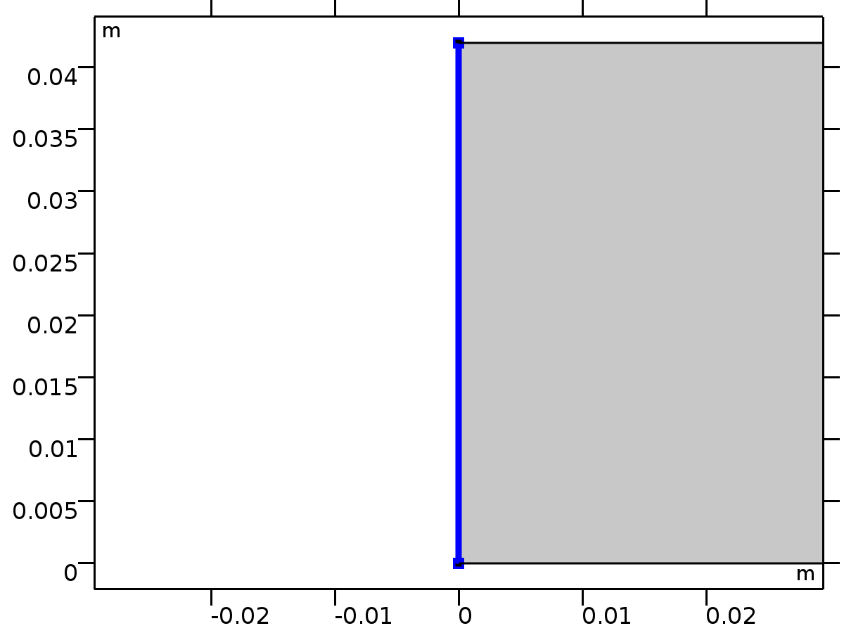
Inlet 1
Selection
Geometric entity level | Boundary
Selection | Boundary 1

Equations
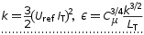
Settings
Description | Value
Boundary condition | Velocity
Velocity field componentwise | Normal inflow velocity
Normal inflow velocity | U
 | Specify turbulent length scale and intensity
Turbulent intensity | spf.IT_init
Turbulence length scale | spf.LT_init
Use weak constraints | Off
Apply reaction terms on | All physics (symmetric)
Constraint method | Elemental

Variables
Name | Expression | Unit | Description | Selection
spf.ubndx | -nojac(spf.nxmesh)*spf.U0in | m/s | Velocity at boundary, x component | Boundary 1
spf.ubndy | -nojac(spf.nymesh)*spf.U0in | m/s | Velocity at boundary, y component | Boundary 1
spf.ubndz | -nojac(spf.nzmesh)*spf.U0in | m/s | Velocity at boundary, z component | Boundary 1
spf.U0in | U | m/s | Normal inflow velocity | Boundary 1
spf.IT | spf.IT_init | 1 | Turbulent intensity | Boundary 1
spf.LT | spf.LT_init | m | Turbulence length scale | Boundary 1
spf.k0 | 1.5*(spf.IT*spf.U0in)^2 | m²/s² | Turbulent kinetic energy | Boundary 1
spf.ep0 | spf.C_mu^0.75*spf.k0^1.5/spf.LT | m²/s³ | Turbulent dissipation rate | Boundary 1
spf.IT_init | 0.05 | 1 | Turbulent intensity | Boundary 1
spf.LT_init | 0.01 | m | Turbulence length scale | Boundary 1
spf.zeta0_init | 2/3 | 1 | Turbulent relative fluctuations | Boundary 1
spf.alpha0_init | 1 | 1 | Elliptic blending function | Boundary 1

Shape functions
Constraint | Constraint force | Shape function | Selection
-u+spf.ubndx | test(-u+spf.ubndx) | Lagrange (Linear) | Boundary 1
-v+spf.ubndy | test(-v+spf.ubndy) | Lagrange (Linear) | Boundary 1
spf.ubndz | test(spf.ubndz) |  | Boundary 1
-ep+spf.ep0 | test(-ep+spf.ep0) | Lagrange (Linear) | Boundary 1
-k+spf.k0 | test(-k+spf.k0) | Lagrange (Linear) | Boundary 1

Outlet 1
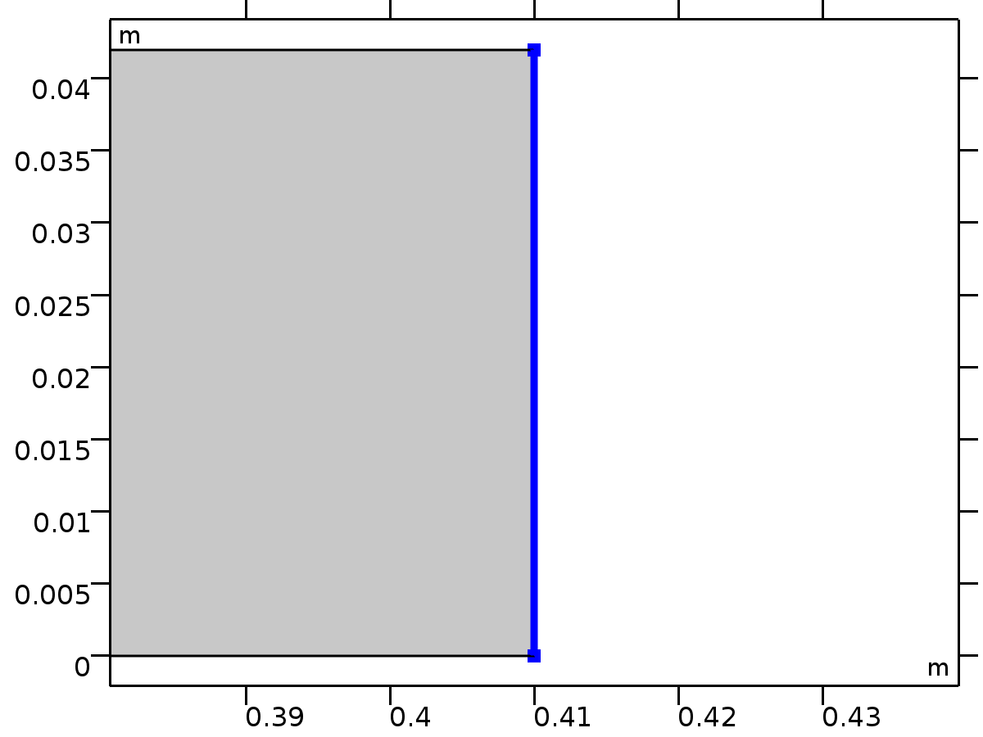
Outlet 1
Selection
Geometric entity level | Boundary
Selection | Boundary 12

Equations
Settings
Description | Value
Boundary condition | Pressure
Pressure | 0
Normal flow | Off
Suppress backflow | On
Use weak constraints | Off
Apply reaction terms on | All physics (symmetric)
Constraint method | Elemental

Variables
Name | Expression | Unit | Description | Selection
spf.rhoFace | down(spf.rho) | kg/m³ | Density face value | Boundary 12
spf.c_here | 96/spf.epsilon_p | 1 | Intermediate variable | Boundary 12
spf.meshVol | meshvol_spatial | m |  | Boundary 12
spf.meshVolInt | down(meshvol_spatial) | m² | Volume of interior mesh element | Boundary 12
spf.umxTnFace | spf.upwind_helpx*spf.nxmesh+spf.upwind_helpy*spf.nymesh+spf.upwind_helpz*spf.nzmesh | m/s | Relative velocity on face | Boundary 12
spf.upwind_ns | spf.backflowPenaltyConv*spf.uNormal | Pa | Upwind term | Boundary 12
spf.p0 | 0 | Pa | Pressure | Boundary 12
spf.out1.Uav | 0 | m/s | Average velocity | Global
spf.isPressure | 1 |  | Help variable | Boundary 12
spf.f0 | spf.p0+spf.uNormal*(spf.backflowPenaltyDiff-spf.backflowPenaltyConv)*(spf.uNormal<0) | N/m² | Normal stress | Boundary 12
spf.uNormal | u*nojac(spf.nxmesh)+v*nojac(spf.nymesh) | m/s | Normal velocity | Boundary 12
spf.backflowPenaltyDiff | spf.c_here*min((down(spf.mu)+spf.muT)*spf.meshVol/spf.meshVolInt,down(spf.rho)*abs(spf.uNormal)/down(spf.epsilon_p)) | Pa·s/m | Backflow penalty parameter, diffusive contribution | Boundary 12
spf.backflowPenaltyConv | spf.rhoFace*spf.umxTnFace/spf.epsilon_p^2 | kg/(m²·s) | Backflow penalty parameter, convective contribution | Boundary 12
spf.out1.Mflow | spf.out1.intFlow(spf.rho*(spf.nx*u+spf.ny*v)) | kg/s | Mass flow | Global

Weak expressions
Weak expression | Integration order | Integration frame | Selection
-spf.f0*(test(u)*spf.nxmesh+test(v)*spf.nymesh) | 2 | Spatial | Boundary 12

Mesh 1
Mesh statistics
Description | Value
Minimum element quality | 0.1879
Average element quality | 0.8123
Triangular elements | 16994
Quadrilateral elements | 3530
Edge elements | 774
Vertex elements | 12

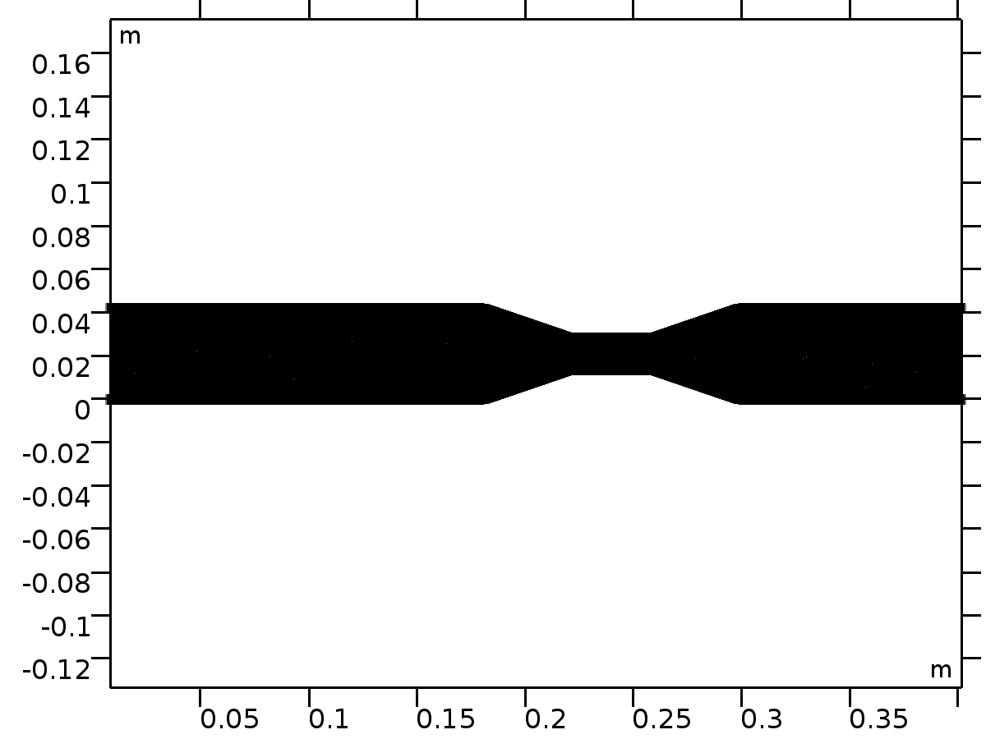
Mesh 1
Size (size)
Settings
Description | Value
Calibrate for | Fluid dynamics
Maximum element size | 0.00189
Minimum element size | 8.4E-5
Curvature factor | 0.3
Maximum element growth rate | 1.15

Size 1 (size1)
Selection
Geometric entity level | Boundary
Selection | Boundaries 2–11

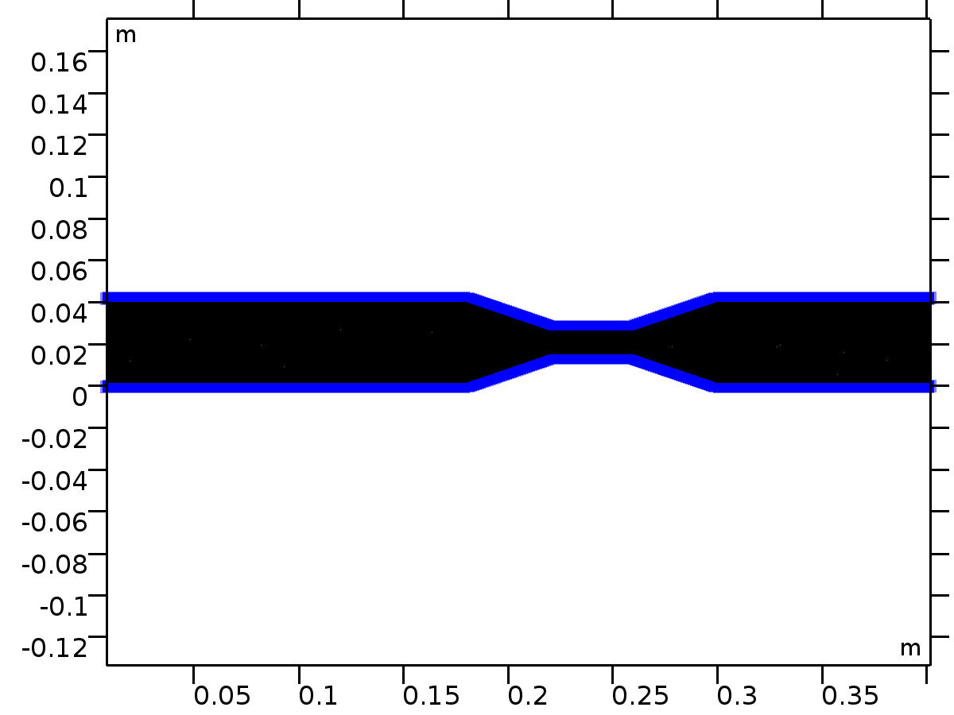
Size 1
Settings
Description | Value
Calibrate for | Fluid dynamics
Maximum element size | 0.00118
Minimum element size | 1.68E-5
Curvature factor | 0.25
Predefined size | Finer

Corner Refinement 1 (cr1)
Selection
Geometric entity level | Domain
Selection | Domain 1

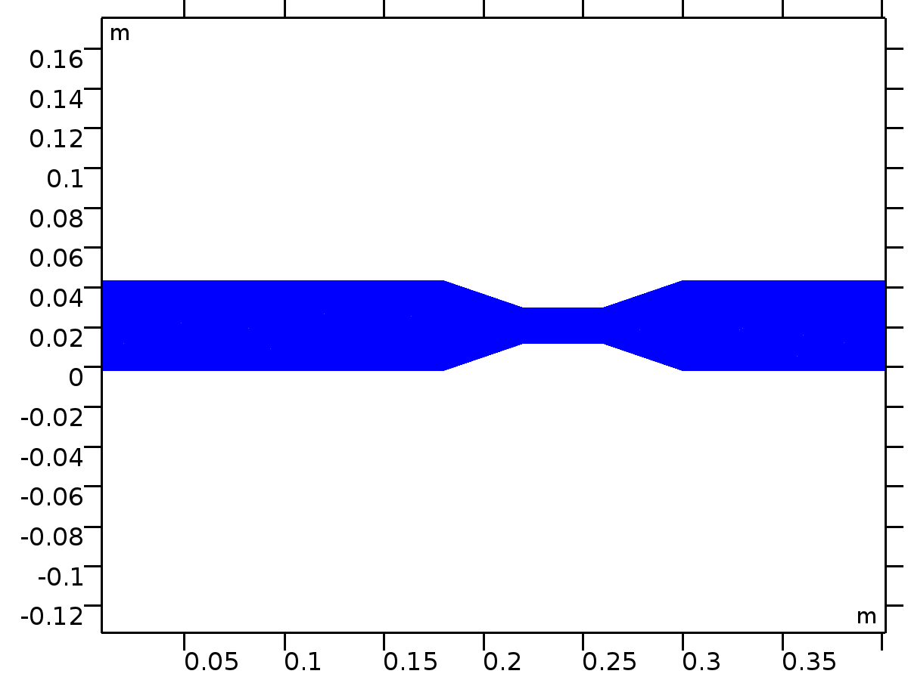
Corner Refinement 1
Free Triangular 1 (ftri1)
Selection
Geometric entity level | Remaining

Free Triangular 1
Boundary Layers 1 (bl1)
Selection
Geometric entity level | Domain
Selection | Domain 1

Boundary Layers 1
Settings
Description | Value
Handling of sharp corners | Trimming

Boundary Layer Properties 1 (blp1)
Selection
Geometric entity level | Boundary
Selection | Boundaries 2–11

Boundary Layer Properties 1
Settings
Description | Value
Number of boundary layers | 5
Thickness adjustment factor | 2.5

Study 1
Computation information
Computation time | 2 min 4 s
CPU | Intel(R) Core(TM) i7-2640M CPU @ 2.80GHz, 2 cores
Operating system | Windows 7

Stationary
Study settings
Description | Value
Include geometric nonlinearity | Off

Physics and variables selection
Physics interface | Discretization
Turbulent Flow, k-ε (spf) | physics

Mesh selection
Geometry | Mesh
Geometry 1 (geom1) | mesh1

Solver Configurations
Solution 1
Compile Equations: Stationary (st1)
Study and step
Description | Value
Use study
Use study step

Log
<---- Compile Equations: Stationary in Study 1/Solution 1 (sol1) ---------------
Started at 9-Jan-2025 03:32:35.
Geometry shape order: Linear
Running on Intel(R) Core(TM) i7-2640M CPU at 2.80 GHz.
Using 2 cores on 1 socket.
Available memory: 4.00 GB.
Time: 2 s.
Physical memory: 876 MB
Virtual memory: 1014 MB
Ended at 9-Jan-2025 03:32:36.
----- Compile Equations: Stationary in Study 1/Solution 1 (sol1) -------------->
Dependent Variables 1 (v1)
General
Description | Value
Defined by study step

Turbulent dissipation rate (comp1.ep) (comp1_ep)
General
Description | Value
Field components | comp1.ep

Turbulent kinetic energy (comp1.k) (comp1_k)
General
Description | Value
Field components | comp1.k

Pressure (comp1.p) (comp1_p)
General
Description | Value
Field components | comp1.p

Velocity field (comp1.u) (comp1_u)
General
Description | Value
Field components | {comp1.u, comp1.v}

Stationary Solver 1 (s1)
General
Description | Value
Defined by study step

Log
0.13
Segregated solver iteration 9.
Velocity u, Pressure p
Iter SolEst Damping Stepsize #Res #Jac #Sol LinErr LinRes
1 0.75 0.5000000 0.75 18 9 9 6e-011 8.8e-014
Turbulence variables
Iter SolEst ResEst Damping Stepsize #Res #Jac #Sol LinErr LinRes
1 0.063 3.8e+004 0.3500000 0.063 34 25 25 3.5e-013 6.4e-016
2 0.061 3.8e+004 0.3500000 0.061 35 26 26 3.4e-013 5.8e-016
3 0.06 3.8e+004 0.3500000 0.06 36 27 27 2.7e-013 6e-016
Solution error estimates for segregated groups
0.38, 0.065
Residual error estimates for segregated groups
2.5e+003, 3.7e+004
Pseudo time-stepping CFL-ratio:
0.11
Segregated solver iteration 10.
Velocity u, Pressure p
Iter SolEst Damping Stepsize #Res #Jac #Sol LinErr LinRes
1 0.71 0.5000000 0.71 20 10 10 3.3e-011 8.6e-014
Turbulence variables
Iter SolEst ResEst Damping Stepsize #Res #Jac #Sol LinErr LinRes
1 0.078 3.8e+004 0.3500000 0.078 38 28 28 3e-013 7.4e-016
2 0.075 3.8e+004 0.3500000 0.075 39 29 29 3.4e-013 6.9e-016
3 0.073 3.8e+004 0.3500000 0.073 40 30 30 3.7e-013 6.5e-016
Solution error estimates for segregated groups
0.35, 0.08
Residual error estimates for segregated groups
1.8e+003, 3.8e+004
Pseudo time-stepping CFL-ratio:
0.15
Segregated solver iteration 11.
Velocity u, Pressure p
Iter SolEst Damping Stepsize #Res #Jac #Sol LinErr LinRes
1 0.51 0.5000000 0.51 22 11 11 4e-011 7e-014
Turbulence variables
Iter SolEst ResEst Damping Stepsize #Res #Jac #Sol LinErr LinRes
1 0.068 3.8e+004 0.3500000 0.068 42 31 31 2.9e-013 6.4e-016
2 0.066 3.8e+004 0.3500000 0.066 43 32 32 2.9e-013 6.1e-016
3 0.064 3.8e+004 0.3500000 0.064 44 33 33 3.1e-013 5.8e-016
Solution error estimates for segregated groups
0.25, 0.07
Residual error estimates for segregated groups
1.5e+003, 3.8e+004
Pseudo time-stepping CFL-ratio:
0.14
Segregated solver iteration 12.
Velocity u, Pressure p
Iter SolEst Damping Stepsize #Res #Jac #Sol LinErr LinRes
1 0.35 0.5000000 0.35 24 12 12 4.9e-011 4.9e-014
Turbulence variables
Iter SolEst ResEst Damping Stepsize #Res #Jac #Sol LinErr LinRes
1 0.075 3.8e+004 0.3500000 0.075 46 34 34 3.3e-013 6.8e-016
2 0.073 3.8e+004 0.3500000 0.073 47 35 35 3.3e-013 6.7e-016
3 0.071 3.8e+004 0.3500000 0.071 48 36 36 3e-013 6.6e-016
Solution error estimates for segregated groups
0.18, 0.077
Residual error estimates for segregated groups
1.3e+003, 3.8e+004
Pseudo time-stepping CFL-ratio:
0.16
Segregated solver iteration 13.
Velocity u, Pressure p
Iter SolEst Damping Stepsize #Res #Jac #Sol LinErr LinRes
1 0.23 0.5000000 0.23 26 13 13 5e-011 3.1e-014
Turbulence variables
Iter SolEst ResEst Damping Stepsize #Res #Jac #Sol LinErr LinRes
1 0.08 3.9e+004 0.3500000 0.08 50 37 37 3.4e-013 7.4e-016
2 0.077 3.9e+004 0.3500000 0.077 51 38 38 3.6e-013 6.6e-016
3 0.075 3.9e+004 0.3500000 0.075 52 39 39 3.3e-013 6.3e-016
Solution error estimates for segregated groups
0.11, 0.082
Residual error estimates for segregated groups
1.2e+003, 3.9e+004
Pseudo time-stepping CFL-ratio:
0.18
Segregated solver iteration 14.
Velocity u, Pressure p
Iter SolEst Damping Stepsize #Res #Jac #Sol LinErr LinRes
1 0.15 0.5000000 0.15 28 14 14 2.8e-011 1.9e-014
Turbulence variables
Iter SolEst ResEst Damping Stepsize #Res #Jac #Sol LinErr LinRes
1 0.086 3.9e+004 0.3500000 0.086 54 40 40 4e-013 7.3e-016
2 0.083 3.9e+004 0.3500000 0.083 55 41 41 4e-013 7.1e-016
3 0.08 3.9e+004 0.3500000 0.08 56 42 42 3.9e-013 6.8e-016
Solution error estimates for segregated groups
0.073, 0.089
Residual error estimates for segregated groups
1.1e+003, 3.9e+004
Pseudo time-stepping CFL-ratio:
0.19
Segregated solver iteration 15.
Velocity u, Pressure p
Iter SolEst Damping Stepsize #Res #Jac #Sol LinErr LinRes
1 0.11 0.5000000 0.11 30 15 15 1.6e-011 1.3e-014
Turbulence variables
Iter SolEst ResEst Damping Stepsize #Res #Jac #Sol LinErr LinRes
1 0.089 3.9e+004 0.3500000 0.089 58 43 43 3.9e-013 7.2e-016
2 0.085 3.9e+004 0.3500000 0.085 59 44 44 3.4e-013 6.8e-016
3 0.082 3.9e+004 0.3500000 0.082 60 45 45 4.3e-013 6.1e-016
Solution error estimates for segregated groups
0.055, 0.092
Residual error estimates for segregated groups
1.1e+003, 3.8e+004
Pseudo time-stepping CFL-ratio:
0.21
Segregated solver iteration 16.
Velocity u, Pressure p
Iter SolEst Damping Stepsize #Res #Jac #Sol LinErr LinRes
1 0.096 0.5000000 0.096 32 16 16 1.1e-011 1.1e-014
Turbulence variables
Iter SolEst ResEst Damping Stepsize #Res #Jac #Sol LinErr LinRes
1 0.087 3.9e+004 0.3500000 0.087 62 46 46 3.6e-013 6.1e-016
2 0.084 3.9e+004 0.3500000 0.084 63 47 47 4.6e-013 6.1e-016
3 0.081 3.8e+004 0.3500000 0.081 64 48 48 4.2e-013 5.4e-016
Solution error estimates for segregated groups
0.048, 0.09
Residual error estimates for segregated groups
1e+003, 3.8e+004
Pseudo time-stepping CFL-ratio:
0.22
Segregated solver iteration 17.
Velocity u, Pressure p
Iter SolEst Damping Stepsize #Res #Jac #Sol LinErr LinRes
1 0.09 0.5000000 0.09 34 17 17 3.3e-012 1.1e-014
Turbulence variables
Iter SolEst ResEst Damping Stepsize #Res #Jac #Sol LinErr LinRes
1 0.084 3.9e+004 0.3500000 0.084 66 49 49 3.6e-013 5.8e-016
2 0.081 3.9e+004 0.3500000 0.081 67 50 50 3.8e-013 5.5e-016
3 0.079 3.8e+004 0.3500000 0.079 68 51 51 4e-013 5.1e-016
Solution error estimates for segregated groups
0.045, 0.088
Residual error estimates for segregated groups
9.3e+002, 3.8e+004
Pseudo time-stepping CFL-ratio:
0.22
Segregated solver iteration 18.
Velocity u, Pressure p
Iter SolEst Damping Stepsize #Res #Jac #Sol LinErr LinRes
1 0.085 0.5000000 0.085 36 18 18 9.2e-013 1.1e-014
Turbulence variables
Iter SolEst ResEst Damping Stepsize #Res #Jac #Sol LinErr LinRes
1 0.081 3.9e+004 0.3500000 0.081 70 52 52 3.3e-013 5.3e-016
2 0.079 3.9e+004 0.3500000 0.079 71 53 53 3.9e-013 4.9e-016
3 0.076 3.8e+004 0.3500000 0.076 72 54 54 3.5e-013 4.8e-016
Solution error estimates for segregated groups
0.043, 0.085
Residual error estimates for segregated groups
8.6e+002, 3.8e+004
Pseudo time-stepping CFL-ratio:
0.23
Segregated solver iteration 19.
Velocity u, Pressure p
Iter SolEst Damping Stepsize #Res #Jac #Sol LinErr LinRes
1 0.081 0.5000000 0.081 38 19 19 1.1e-012 1.2e-014
Turbulence variables
Iter SolEst ResEst Damping Stepsize #Res #Jac #Sol LinErr LinRes
1 0.079 3.9e+004 0.3500000 0.079 74 55 55 3.3e-013 4.9e-016
2 0.076 3.9e+004 0.3500000 0.076 75 56 56 3.4e-013 4.7e-016
3 0.074 3.8e+004 0.3500000 0.074 76 57 57 3.1e-013 4.3e-016
Solution error estimates for segregated groups
0.04, 0.083
Residual error estimates for segregated groups
8e+002, 3.8e+004
Pseudo time-stepping CFL-ratio:
0.23
Segregated solver iteration 20.
Velocity u, Pressure p
Iter SolEst Damping Stepsize #Res #Jac #Sol LinErr LinRes
1 0.076 0.5000000 0.076 40 20 20 2.3e-012 1.2e-014
Turbulence variables
Iter SolEst ResEst Damping Stepsize #Res #Jac #Sol LinErr LinRes
1 0.077 3.9e+004 0.3500000 0.077 78 58 58 3.3e-013 4.6e-016
2 0.074 3.8e+004 0.3500000 0.074 79 59 59 3.5e-013 4.2e-016
3 0.072 3.8e+004 0.3500000 0.072 80 60 60 3.9e-013 4.5e-016
Solution error estimates for segregated groups
0.038, 0.08
Residual error estimates for segregated groups
7.4e+002, 3.8e+004
Pseudo time-stepping CFL-ratio:
0.24
Segregated solver iteration 21.
Velocity u, Pressure p
Iter SolEst Damping Stepsize #Res #Jac #Sol LinErr LinRes
1 0.072 0.5000000 0.072 42 21 21 3.2e-012 1.3e-014
Turbulence variables
Iter SolEst ResEst Damping Stepsize #Res #Jac #Sol LinErr LinRes
1 0.075 3.9e+004 0.3500000 0.075 82 61 61 3.1e-013 4.7e-016
2 0.072 3.8e+004 0.3500000 0.072 83 62 62 3.2e-013 4.4e-016
3 0.07 3.8e+004 0.3500000 0.07 84 63 63 4.4e-013 4.7e-016
Solution error estimates for segregated groups
0.036, 0.078
Residual error estimates for segregated groups
6.8e+002, 3.8e+004
Pseudo time-stepping CFL-ratio:
0.24
Segregated solver iteration 22.
Velocity u, Pressure p
Iter SolEst Damping Stepsize #Res #Jac #Sol LinErr LinRes
1 0.068 0.5000000 0.068 44 22 22 3.1e-012 1.3e-014
Turbulence variables
Iter SolEst ResEst Damping Stepsize #Res #Jac #Sol LinErr LinRes
1 0.073 3.8e+004 0.3500000 0.073 86 64 64 3.4e-013 4.7e-016
2 0.07 3.8e+004 0.3500000 0.07 87 65 65 3.9e-013 5.2e-016
3 0.067 3.8e+004 0.3500000 0.067 88 66 66 3e-013 4.1e-016
Solution error estimates for segregated groups
0.034, 0.075
Residual error estimates for segregated groups
6.3e+002, 3.8e+004
Pseudo time-stepping CFL-ratio:
0.25
Segregated solver iteration 23.
Velocity u, Pressure p
Iter SolEst Damping Stepsize #Res #Jac #Sol LinErr LinRes
1 0.064 0.5000000 0.064 46 23 23 8.4e-012 1.4e-014
Turbulence variables
Iter SolEst ResEst Damping Stepsize #Res #Jac #Sol LinErr LinRes
1 0.07 3.8e+004 0.3500000 0.07 90 67 67 3.9e-013 5.7e-016
2 0.067 3.8e+004 0.3500000 0.067 91 68 68 3.8e-013 4.4e-016
3 0.064 3.8e+004 0.3500000 0.064 92 69 69 3.8e-013 4.5e-016
Solution error estimates for segregated groups
0.032, 0.072
Residual error estimates for segregated groups
5.9e+002, 3.8e+004
Pseudo time-stepping CFL-ratio:
0.26
Segregated solver iteration 24.
Velocity u, Pressure p
Iter SolEst Damping Stepsize #Res #Jac #Sol LinErr LinRes
1 0.061 0.5000000 0.061 48 24 24 7.2e-012 1.5e-014
Turbulence variables
Iter SolEst ResEst Damping Stepsize #Res #Jac #Sol LinErr LinRes
1 0.067 3.8e+004 0.3500000 0.067 94 70 70 3.8e-013 4.8e-016
2 0.064 3.8e+004 0.3500000 0.064 95 71 71 3.7e-013 4.5e-016
3 0.061 3.8e+004 0.3500000 0.061 96 72 72 3.3e-013 4.5e-016
Solution error estimates for segregated groups
0.03, 0.069
Residual error estimates for segregated groups
5.6e+002, 3.7e+004
Pseudo time-stepping CFL-ratio:
0.26
Segregated solver iteration 25.
Velocity u, Pressure p
Iter SolEst Damping Stepsize #Res #Jac #Sol LinErr LinRes
1 0.058 0.5000000 0.058 50 25 25 4.3e-012 1.5e-014
Turbulence variables
Iter SolEst ResEst Damping Stepsize #Res #Jac #Sol LinErr LinRes
1 0.064 3.8e+004 0.3500000 0.064 98 73 73 3.8e-013 4.8e-016
2 0.06 3.7e+004 0.3500000 0.06 99 74 74 3.8e-013 4.4e-016
3 0.056 3.7e+004 0.3500000 0.056 100 75 75 4.4e-013 4.5e-016
Solution error estimates for segregated groups
0.029, 0.064
Residual error estimates for segregated groups
5.3e+002, 3.7e+004
Pseudo time-stepping CFL-ratio:
0.27
Segregated solver iteration 26.
Velocity u, Pressure p
Iter SolEst Damping Stepsize #Res #Jac #Sol LinErr LinRes
1 0.054 0.5000000 0.054 52 26 26 1.1e-011 1.6e-014
Turbulence variables
Iter SolEst ResEst Damping Stepsize #Res #Jac #Sol LinErr LinRes
1 0.059 3.7e+004 0.3500000 0.059 102 76 76 4.2e-013 5.2e-016
2 0.055 3.7e+004 0.3500000 0.055 103 77 77 4.1e-013 4.6e-016
3 0.052 3.7e+004 0.3500000 0.052 104 78 78 4e-013 4.7e-016
Solution error estimates for segregated groups
0.027, 0.059
Residual error estimates for segregated groups
5.1e+002, 3.7e+004
Pseudo time-stepping CFL-ratio:
0.28
Segregated solver iteration 27.
Velocity u, Pressure p
Iter SolEst Damping Stepsize #Res #Jac #Sol LinErr LinRes
1 0.052 0.5000000 0.052 54 27 27 7.7e-012 1.6e-014
Turbulence variables
Iter SolEst ResEst Damping Stepsize #Res #Jac #Sol LinErr LinRes
1 0.055 3.7e+004 0.3500000 0.055 106 79 79 3.9e-013 4.7e-016
2 0.051 3.7e+004 0.3500000 0.051 107 80 80 3.2e-013 4.3e-016
3 0.047 3.6e+004 0.3500000 0.047 108 81 81 4e-013 4.2e-016
Solution error estimates for segregated groups
0.026, 0.054
Residual error estimates for segregated groups
4.9e+002, 3.6e+004
Pseudo time-stepping CFL-ratio:
0.29
Segregated solver iteration 28.
Velocity u, Pressure p
Iter SolEst Damping Stepsize #Res #Jac #Sol LinErr LinRes
1 0.049 0.5000000 0.049 56 28 28 5.7e-012 1.7e-014
Turbulence variables
Iter SolEst ResEst Damping Stepsize #Res #Jac #Sol LinErr LinRes
1 0.05 3.6e+004 0.3500000 0.05 110 82 82 3.4e-013 4.3e-016
2 0.046 3.6e+004 0.3500000 0.046 111 83 83 4.3e-013 4.5e-016
3 0.043 3.6e+004 0.3500000 0.043 112 84 84 3.7e-013 4.3e-016
Solution error estimates for segregated groups
0.025, 0.049
Residual error estimates for segregated groups
4.7e+002, 3.5e+004
Pseudo time-stepping CFL-ratio:
0.3
Segregated solver iteration 29.
Velocity u, Pressure p
Iter SolEst Damping Stepsize #Res #Jac #Sol LinErr LinRes
1 0.048 0.5000000 0.048 58 29 29 1e-012 1.7e-014
Turbulence variables
Iter SolEst ResEst Damping Stepsize #Res #Jac #Sol LinErr LinRes
1 0.045 3.6e+004 0.3500000 0.045 114 85 85 4.6e-013 4.5e-016
2 0.041 3.5e+004 0.3500000 0.041 115 86 86 4.4e-013 4.4e-016
3 0.038 3.5e+004 0.3500000 0.038 116 87 87 3.6e-013 4.3e-016
Solution error estimates for segregated groups
0.024, 0.044
Residual error estimates for segregated groups
4.5e+002, 3.5e+004
Pseudo time-stepping CFL-ratio:
0.31
Segregated solver iteration 30.
Velocity u, Pressure p
Iter SolEst Damping Stepsize #Res #Jac #Sol LinErr LinRes
1 0.048 0.5000000 0.048 60 30 30 3e-012 1.8e-014
Turbulence variables
Iter SolEst ResEst Damping Stepsize #Res #Jac #Sol LinErr LinRes
1 0.04 3.5e+004 0.3500000 0.04 118 88 88 4.3e-013 4e-016
2 0.037 3.5e+004 0.3500000 0.037 119 89 89 4.1e-013 4e-016
3 0.034 3.4e+004 0.3500000 0.034 120 90 90 3.5e-013 3.6e-016
Solution error estimates for segregated groups
0.024, 0.04
Residual error estimates for segregated groups
4.2e+002, 3.4e+004
Pseudo time-stepping CFL-ratio:
0.32
Segregated solver iteration 31.
Velocity u, Pressure p
Iter SolEst Damping Stepsize #Res #Jac #Sol LinErr LinRes
1 0.048 0.5000000 0.048 62 31 31 1.1e-012 1.9e-014
Turbulence variables
Iter SolEst ResEst Damping Stepsize #Res #Jac #Sol LinErr LinRes
1 0.036 3.4e+004 0.3500000 0.036 122 91 91 3.6e-013 3.4e-016
2 0.032 3.4e+004 0.3500000 0.032 123 92 92 3.5e-013 3.5e-016
3 0.03 3.4e+004 0.3500000 0.03 124 93 93 4e-013 3.5e-016
Solution error estimates for segregated groups
0.024, 0.035
Residual error estimates for segregated groups
3.9e+002, 3.4e+004
Pseudo time-stepping CFL-ratio:
0.33
Segregated solver iteration 32.
Velocity u, Pressure p
Iter SolEst Damping Stepsize #Res #Jac #Sol LinErr LinRes
1 0.049 0.5000000 0.049 64 32 32 1.2e-012 2e-014
Turbulence variables
Iter SolEst ResEst Damping Stepsize #Res #Jac #Sol LinErr LinRes
1 0.031 3.4e+004 0.3500000 0.031 126 94 94 4e-013 2.9e-016
2 0.028 3.3e+004 0.3500000 0.028 127 95 95 3.5e-013 3.3e-016
3 0.025 3.3e+004 0.3500000 0.025 128 96 96 3.2e-013 3.6e-016
Solution error estimates for segregated groups
0.024, 0.03
Residual error estimates for segregated groups
3.5e+002, 3.3e+004
Pseudo time-stepping CFL-ratio:
0.35
Segregated solver iteration 33.
Velocity u, Pressure p
Iter SolEst Damping Stepsize #Res #Jac #Sol LinErr LinRes
1 0.048 0.5000000 0.048 66 33 33 2.2e-012 2.2e-014
Turbulence variables
Iter SolEst ResEst Damping Stepsize #Res #Jac #Sol LinErr LinRes
1 0.027 3.3e+004 0.3500000 0.027 130 97 97 4.4e-013 2.7e-016
2 0.023 3.3e+004 0.3500000 0.023 131 98 98 3.4e-013 2.9e-016
3 0.021 3.3e+004 0.3500000 0.021 132 99 99 3e-013 2.3e-016
Solution error estimates for segregated groups
0.024, 0.025
Residual error estimates for segregated groups
3.1e+002, 3.3e+004
Pseudo time-stepping CFL-ratio:
0.36
Segregated solver iteration 34.
Velocity u, Pressure p
Iter SolEst Damping Stepsize #Res #Jac #Sol LinErr LinRes
1 0.046 0.5000000 0.046 68 34 34 1.2e-012 2.4e-014
Turbulence variables
Iter SolEst ResEst Damping Stepsize #Res #Jac #Sol LinErr LinRes
1 0.023 3.3e+004 0.3500000 0.023 134 100 100 4e-013 2.7e-016
2 0.019 3.2e+004 0.3500000 0.019 135 101 101 3.5e-013 3.1e-016
3 0.016 3.2e+004 0.3500000 0.016 136 102 102 3.2e-013 3.8e-016
Solution error estimates for segregated groups
0.023, 0.021
Residual error estimates for segregated groups
2.7e+002, 3.2e+004
Pseudo time-stepping CFL-ratio:
0.37
Segregated solver iteration 35.
Velocity u, Pressure p
Iter SolEst Damping Stepsize #Res #Jac #Sol LinErr LinRes
1 0.043 0.5000000 0.043 70 35 35 8.5e-013 2.6e-014
Turbulence variables
Iter SolEst ResEst Damping Stepsize #Res #Jac #Sol LinErr LinRes
1 0.02 3.2e+004 0.3500000 0.02 138 103 103 3.8e-013 2.5e-016
2 0.016 3.2e+004 0.3500000 0.016 139 104 104 3.3e-013 2.6e-016
3 0.013 3.2e+004 0.3500000 0.013 140 105 105 1.9e-013 1.9e-016
Solution error estimates for segregated groups
0.021, 0.017
Residual error estimates for segregated groups
2.2e+002, 3.2e+004
Pseudo time-stepping CFL-ratio:
0.39
Segregated solver iteration 36.
Velocity u, Pressure p
Iter SolEst Damping Stepsize #Res #Jac #Sol LinErr LinRes
1 0.037 0.5000000 0.037 72 36 36 1.8e-012 2.7e-014
Turbulence variables
Iter SolEst ResEst Damping Stepsize #Res #Jac #Sol LinErr LinRes
1 0.018 3.2e+004 0.3500000 0.018 142 106 106 2.5e-013 2.2e-016
2 0.014 3.2e+004 0.3500000 0.014 143 107 107 2e-013 1.9e-016
3 0.01 3.2e+004 0.3500000 0.01 144 108 108 1.6e-013 1.4e-016
Solution error estimates for segregated groups
0.018, 0.015
Residual error estimates for segregated groups
1.7e+002, 3.2e+004
Pseudo time-stepping CFL-ratio:
0.41
Segregated solver iteration 37.
Velocity u, Pressure p
Iter SolEst Damping Stepsize #Res #Jac #Sol LinErr LinRes
1 0.03 0.5000000 0.03 74 37 37 9.3e-013 2.9e-014
Turbulence variables
Iter SolEst ResEst Damping Stepsize #Res #Jac #Sol LinErr LinRes
1 0.017 3.2e+004 0.3500000 0.017 146 109 109 2.7e-013 2.7e-016
2 0.012 3.2e+004 0.3500000 0.012 147 110 110 1.7e-013 2.2e-016
3 0.0084 3.2e+004 0.3500000 0.0084 148 111 111 1.5e-013 1.5e-016
Solution error estimates for segregated groups
0.015, 0.013
Residual error estimates for segregated groups
1.3e+002, 3.1e+004
Pseudo time-stepping CFL-ratio:
0.43
Segregated solver iteration 38.
Velocity u, Pressure p
Iter SolEst Damping Stepsize #Res #Jac #Sol LinErr LinRes
1 0.023 0.5000000 0.023 76 38 38 8.7e-013 3.1e-014
Turbulence variables
Iter SolEst ResEst Damping Stepsize #Res #Jac #Sol LinErr LinRes
1 0.015 3.2e+004 0.3500000 0.015 150 112 112 2e-013 1.8e-016
2 0.01 3.1e+004 0.3500000 0.01 151 113 113 1.9e-013 1.9e-016
3 0.0071 3.1e+004 0.3500000 0.0071 152 114 114 1.5e-013 1.7e-016
Solution error estimates for segregated groups
0.012, 0.011
Residual error estimates for segregated groups
87, 3.1e+004
Pseudo time-stepping CFL-ratio:
0.45
Segregated solver iteration 39.
Velocity u, Pressure p
Iter SolEst Damping Stepsize #Res #Jac #Sol LinErr LinRes
1 0.017 0.5000000 0.017 78 39 39 1.1e-012 3.5e-014
Turbulence variables
Iter SolEst ResEst Damping Stepsize #Res #Jac #Sol LinErr LinRes
1 0.012 3.1e+004 0.3500000 0.012 154 115 115 2e-013 2.2e-016
2 0.0084 3.1e+004 0.3500000 0.0084 155 116 116 1.7e-013 2.1e-016
3 0.0057 3.1e+004 0.3500000 0.0057 156 117 117 1.5e-013 2.6e-016
Solution error estimates for segregated groups
0.0085, 0.009
Residual error estimates for segregated groups
57, 3.1e+004
Pseudo time-stepping CFL-ratio:
0.48
Segregated solver iteration 40.
Velocity u, Pressure p
Iter SolEst Damping Stepsize #Res #Jac #Sol LinErr LinRes
1 0.012 0.5000000 0.012 80 40 40 1.2e-012 4e-014
Turbulence variables
Iter SolEst ResEst Damping Stepsize #Res #Jac #Sol LinErr LinRes
1 0.0091 3.1e+004 0.3500000 0.0091 158 118 118 1.7e-013 1.6e-016
2 0.0063 3.1e+004 0.3500000 0.0063 159 119 119 1.4e-013 1.6e-016
3 0.0042 3.1e+004 0.3500000 0.0042 160 120 120 9.2e-014 1e-016
Solution error estimates for segregated groups
0.0061, 0.0068
Residual error estimates for segregated groups
35, 3.1e+004
Pseudo time-stepping CFL-ratio:
0.51
Segregated solver iteration 41.
Velocity u, Pressure p
Iter SolEst Damping Stepsize #Res #Jac #Sol LinErr LinRes
1 0.009 0.5000000 0.009 82 41 41 2.7e-012 5.3e-014
Turbulence variables
Iter SolEst ResEst Damping Stepsize #Res #Jac #Sol LinErr LinRes
1 0.0065 3.1e+004 0.3500000 0.0065 162 121 121 1.9e-013 2.4e-016
2 0.0043 3.1e+004 0.3500000 0.0043 163 122 122 1.3e-013 2.8e-016
3 0.0029 3.1e+004 0.3500000 0.0029 164 123 123 1.5e-013 1.9e-016
Solution error estimates for segregated groups
0.0045, 0.0047
Residual error estimates for segregated groups
22, 3.1e+004
Pseudo time-stepping CFL-ratio:
0.55
Segregated solver iteration 42.
Velocity u, Pressure p
Iter SolEst Damping Stepsize #Res #Jac #Sol LinErr LinRes
1 0.0063 0.5000000 0.0063 84 42 42 8e-012 6.3e-014
Turbulence variables
Iter SolEst ResEst Damping Stepsize #Res #Jac #Sol LinErr LinRes
1 0.0044 3.1e+004 0.3500000 0.0044 166 124 124 1.8e-013 2.3e-016
2 0.0028 3.1e+004 0.3500000 0.0028 167 125 125 1.9e-013 2.6e-016
3 0.0019 3.1e+004 0.3500000 0.0019 168 126 126 1.2e-013 2e-016
Solution error estimates for segregated groups
0.0032, 0.0031
Residual error estimates for segregated groups
15, 3.1e+004
Pseudo time-stepping CFL-ratio:
0.59
Segregated solver iteration 43.
Velocity u, Pressure p
Iter SolEst Damping Stepsize #Res #Jac #Sol LinErr LinRes
1 0.0034 0.5000000 0.0034 86 43 43 5.7e-012 5.5e-014
Turbulence variables
Iter SolEst ResEst Damping Stepsize #Res #Jac #Sol LinErr LinRes
1 0.0025 3.1e+004 0.3500000 0.0025 170 127 127 1.2e-013 1.3e-016
2 0.0016 3.1e+004 0.3500000 0.0016 171 128 128 2.2e-013 3.2e-016
3 0.0012 3.1e+004 0.3500000 0.0012 172 129 129 1.2e-013 2e-016
Solution error estimates for segregated groups
0.0017, 0.0018
Residual error estimates for segregated groups
10, 3.1e+004
Pseudo time-stepping CFL-ratio:
0.63
Segregated solver iteration 44.
Velocity u, Pressure p
Iter SolEst Damping Stepsize #Res #Jac #Sol LinErr LinRes
1 0.0023 0.5000000 0.0023 88 44 44 2.3e-011 3.5e-014
Turbulence variables
Iter SolEst ResEst Damping Stepsize #Res #Jac #Sol LinErr LinRes
1 0.0013 3.1e+004 0.3500000 0.0013 174 130 130 1.5e-013 2.9e-016
2 0.00086 3.1e+004 0.3500000 0.00086 175 131 131 1.6e-013 2.8e-016
Solution error estimates for segregated groups
0.0012, 0.00084
Residual error estimates for segregated groups
5.7, 3.1e+004
Pseudo time-stepping CFL-ratio:
0.7
Segregated solver iteration 45.
Velocity u, Pressure p
Iter SolEst Damping Stepsize #Res #Jac #Sol LinErr LinRes
1 0.0032 0.5000000 0.0032 90 45 45 3.4e-011 1.1e-013
Turbulence variables
Iter SolEst ResEst Damping Stepsize #Res #Jac #Sol LinErr LinRes
1 0.0016 3.1e+004 0.3500000 0.0016 177 132 132 1.6e-013 3e-016
2 0.00096 3.1e+004 0.3500000 0.00096 178 133 133 1.8e-013 3.8e-016
Solution error estimates for segregated groups
0.0016, 0.0011
Residual error estimates for segregated groups
3, 3.1e+004
Pseudo time-stepping CFL-ratio:
0.76
Segregated solver iteration 46.
Velocity u, Pressure p
Iter SolEst Damping Stepsize #Res #Jac #Sol LinErr LinRes
1 0.00032 0.5000000 0.00032 92 46 46 2.2e-012 1.8e-014
Turbulence variables
Iter SolEst ResEst Damping Stepsize #Res #Jac #Sol LinErr LinRes
1 0.00064 3.1e+004 0.3500000 0.00064 180 134 134 5.8e-014 1.4e-016
Solution error estimates for segregated groups
0.00016, 0.00042
Residual error estimates for segregated groups
1.7, 3.1e+004
Pseudo time-stepping CFL-ratio:
0.76
Segregated solver iteration 47.
Velocity u, Pressure p
Iter SolEst Damping Stepsize #Res #Jac #Sol LinErr LinRes
1 0.0024 0.5000000 0.0024 94 47 47 6.4e-011 2.5e-013
Turbulence variables
Iter SolEst ResEst Damping Stepsize #Res #Jac #Sol LinErr LinRes
1 0.0012 3.1e+004 0.3500000 0.0012 182 135 135 1.1e-013 1.8e-016
2 0.00071 3.1e+004 0.3500000 0.00071 183 136 136 9.2e-014 1.6e-016
Solution error estimates for segregated groups
0.0012, 0.00077
Residual error estimates for segregated groups
1.2, 3.1e+004
Pseudo time-stepping CFL-ratio:
0.91
Segregated solver iteration 48.
Velocity u, Pressure p
Iter SolEst Damping Stepsize #Res #Jac #Sol LinErr LinRes
1 0.00064 0.5000000 0.00064 96 48 48 5.6e-011 8.4e-014
Turbulence variables
Iter SolEst ResEst Damping Stepsize #Res #Jac #Sol LinErr LinRes
1 0.00066 3.1e+004 0.3500000 0.00066 185 137 137 1.4e-013 2.7e-016
Solution error estimates for segregated groups
0.00032, 0.00043
Residual error estimates for segregated groups
1, 3.1e+004
Pseudo time-stepping CFL-ratio:
0.83
Segregated solver iteration 49.
Velocity u, Pressure p
Iter SolEst Damping Stepsize #Res #Jac #Sol LinErr LinRes
1 0.00059 0.5000000 0.00059 98 49 49 2.8e-011 9.3e-014
Turbulence variables
Iter SolEst ResEst Damping Stepsize #Res #Jac #Sol LinErr LinRes
1 0.00014 3.1e+004 0.3500000 0.00014 187 138 138 7.8e-014 1.4e-016
Solution error estimates for segregated groups
0.00029, 9.2e-005
Residual error estimates for segregated groups
0.65, 3.1e+004
Pseudo time-stepping CFL-ratio:
0.94
Segregated solver iteration 50.
Velocity u, Pressure p
Iter SolEst Damping Stepsize #Res #Jac #Sol LinErr LinRes
1 0.0013 0.5000000 0.0013 100 50 50 1.8e-012 2.8e-013
Turbulence variables
Iter SolEst ResEst Damping Stepsize #Res #Jac #Sol LinErr LinRes
1 0.00063 3.1e+004 0.3500000 0.00063 189 139 139 9.8e-014 1.6e-016
Solution error estimates for segregated groups
0.00067, 0.00041
Residual error estimates for segregated groups
0.66, 3.1e+004
Pseudo time-stepping CFL-ratio:
1
Solution time: 122 s. (2 minutes, 2 seconds)
Physical memory: 1.13 GB
Virtual memory: 1.28 GB
Ended at 9-Jan-2025 03:34:39.
----- Stationary Solver 1 in Study 1/Solution 1 (sol1) ------------------------>
Segregated 1 (se1)
General
Description | Value
Maximum number of iterations | 300
Stabilization and acceleration | Pseudo time-stepping
Initial CFL number | 3

Velocity u, Pressure p (ss1)
General
Description | Value
Variables | {Velocity field (comp1.u), Pressure (comp1.p)}
Linear solver

Method and termination
Description | Value
Damping factor | 0.5

Turbulence variables (ss2)
General
Description | Value
Variables | {Turbulent kinetic energy (comp1.k), Turbulent dissipation rate (comp1.ep)}
Linear solver

Method and termination
Description | Value
Damping factor | 0.35
Termination technique | Iterations or tolerance
Number of iterations | 3
Tolerance factor | 1

Lower Limit 1 (ll1)
Lower limit
Description | Value
Lower limits (field variables) | comp1.k 0 comp1.ep 0

Direct 1 (d1)
General
Description | Value
Solver | PARDISO

Direct 2 (d2)
General
Description | Value
Solver | PARDISO

Results
Data Sets
Study 1/Solution 1
Solution
Description | Value
Solution
Component | Save Point Geometry 1

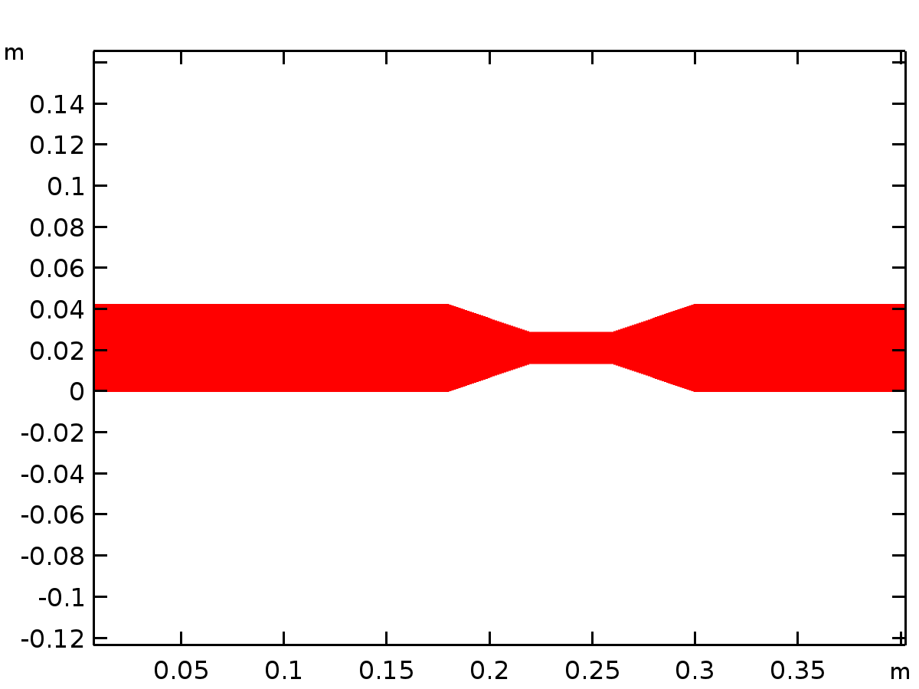
Data set: Study 1/Solution 1
Exterior Walls
Data
Description | Value
Data set

Plot Groups
Velocity (spf)
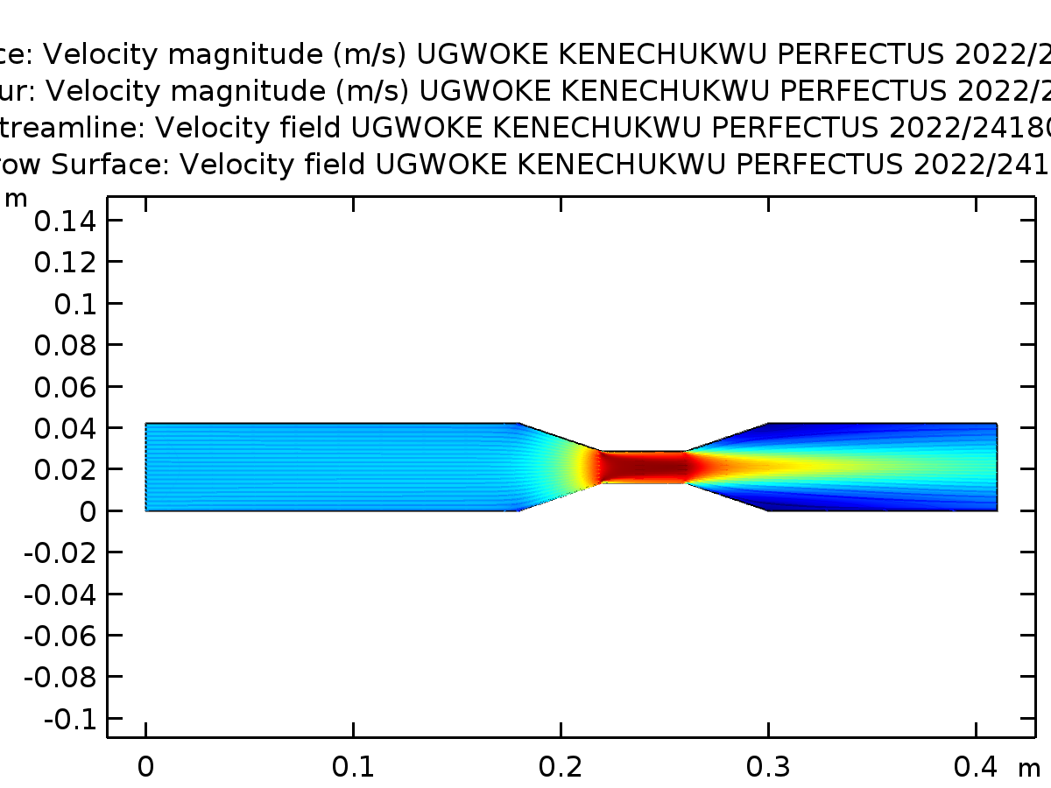
Surface: Velocity magnitude (m/s) UGWOKE KENECHUKWU PERFECTUS 2022/241806 Contour: Velocity magnitude (m/s) UGWOKE KENECHUKWU PERFECTUS 2022/241806 Streamline: Velocity field UGWOKE KENECHUKWU PERFECTUS 2022/241806 Arrow Surface: Velocity field UGWOKE KENECHUKWU PERFECTUS 2022/241806
Pressure (spf)
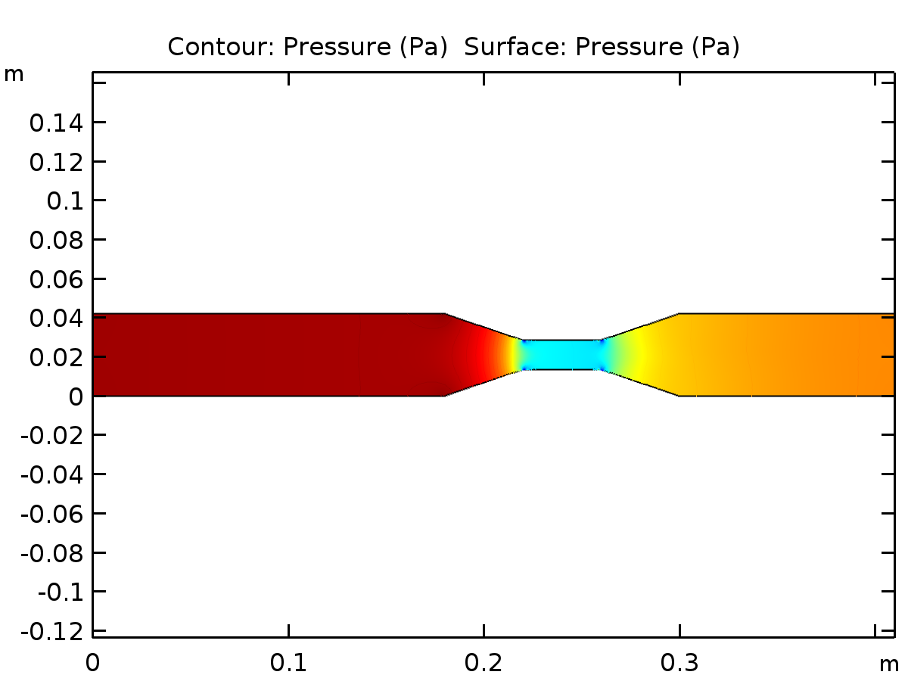
Contour: Pressure (Pa) Surface: Pressure (Pa)
Wall Resolution (spf)
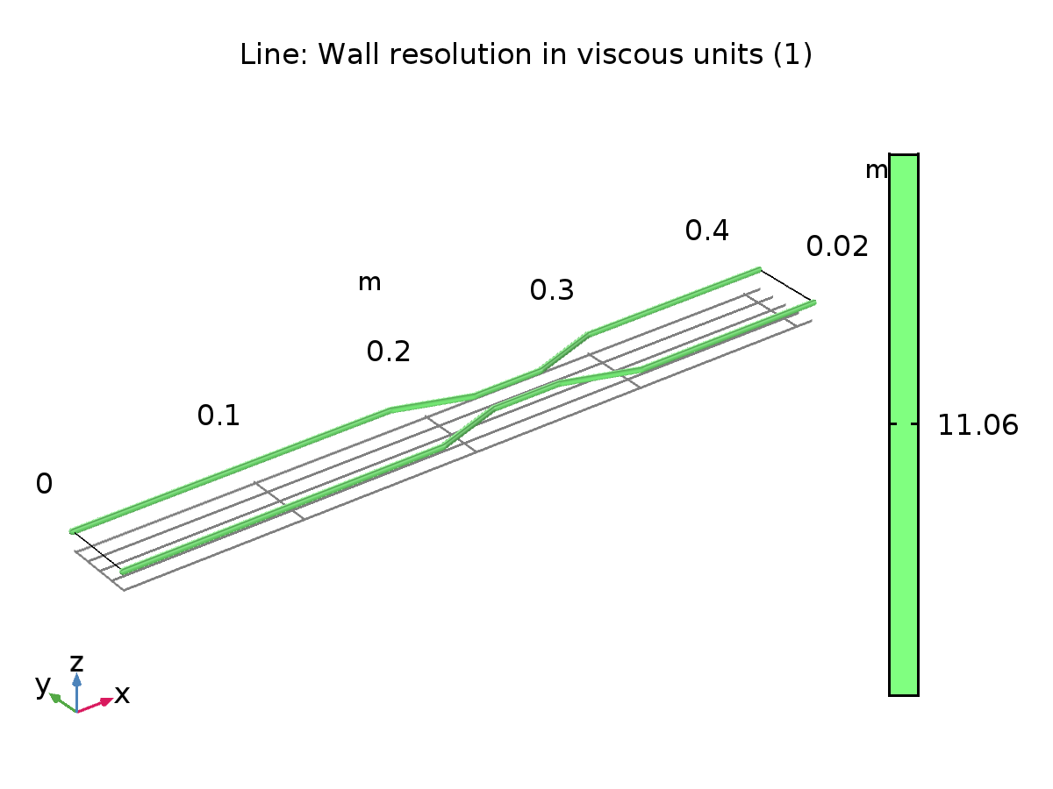
Line: Wall resolution in viscous units (1)

